A-2023-3044236
Date Served: November 16, 2023

DANIEL A. GARCIA
FIRSTENERGY SERVICE COMPANY
800 CABIN HILL DRIVE
GREENSBURG, PA 15601
E-mail: dagarcia@firstenergycorp.com

Application of West Penn Power Company for Approval of the Alteration of Electric Facilities at a Highway and Railroad Crossing of Pennsylvania & Southern Railway, Inc. and Salem Road located in the Greene Township, Franklin County, Pennsylvania

Dear Mr. Garcia:

Receipt is acknowledged of the application of West Penn Power Company which has been captioned and docketed to the above number.

We note that you have served copies of the application upon the parties involved.

The matter will receive the Commission's attention, and you will be advised of any further procedure.

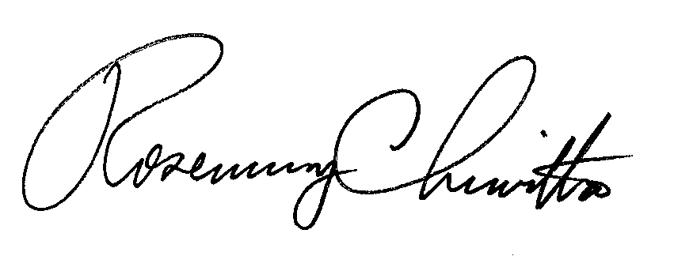
Sincerely,

Rosemary Chiavetta
Secretary

RC: JBS

