 | COMMONWEALTH OF PENNSYLVANIA  PENNSYLVANIA PUBLIC UTILITY COMMISSION  COMMONWEALTH KEYSTONE BUILDING  400 NORTH STREET  HARRISBURG, PENNSYLVANIA 17120 | IN REPLY PLEASE REFER TO OUR FILE

December 12, 2023
C-2023-3039609

Via E-mail: teresa.harrold@amwater.com
TERESA HARROLD
852 WESLEY DR
MECHANICSBURG PA 17055

Vera Scroggins
v.
Pennsylvania American Water Company

Dear Sir/Madam:

Attached is a copy of an amended complaint filed on behalf of the complainant in the above titled proceeding.

Such answer as you desire to make to the amended complaint should be filed in this Office and served upon the complainant within twenty days from receipt of this letter.

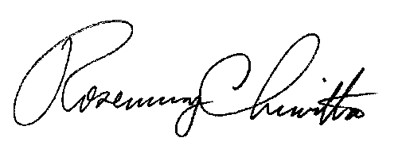
Very truly yours,

Rosemary Chiavetta
Secretary

RC:anc

