BEFORE THE
PENNSYLVANIA PUBLIC UTILITY COMMISSION

Charlene Miller :
: C-2022-3032554
v. :
:
Peoples Natural Gas Company LLC :

FIFTH INTERIM ORDER
OPENING THE RECORD TO MEMORIALIZE
CONVENING OF INFORMAL TELEPHONE CONFERENCE

HISTORY OF TH EPROCEEDINGS

Complainant Charlene Miller (Complainant or Ms. Miller) filed a Formal Complaint against Respondent Peoples Natural Gas Company LLC (Peoples or Respondent) on May 16, 2022. Complainant alleged that on or about April 4, 2022, Respondent changed the address for her gas service at 504 Western Avenue, Apartment 8, East Pittsburgh, Pennsylvania to 502 Western Avenue, Apartment 8, East Pittsburgh, Pennsylvania. Complainant alleges the address change resulted in incorrect charges on her gas bill. Complainant also alleges Respondent is threatening service termination.

On July 6, 2022, Respondent filed an Answer, in pertinent part, as follows:

People avers that the building that Complainant lives in and the actual apartment that she resides in have different street addresses. Although the building as a whole has an address of 301 Bessemer Avenue, East Pittsburgh, PA, Complainant’s unit faces Western Avenue and has an address of 502 Western Avenue. Additionally, Complainant’s address was changed from 504 Western Avenue to 502 Western Avenue due to 911 updates. Regardless of the address changes, Complainant has consistently been billed from the same meter number, which is the meter that serves the apartment she lives in, No. 8. Complainant is responsible for the charges billed to her.

Answer ¶ 4. Respondent also alleges that Complainant presently owes $231.11. Id.

The evidentiary hearing convened in this proceeding on October 19, 2022. Ms. Miller appeared self-represented. Peoples was represented by Jennifer Petrisek, Esquire. While Complainant did not raise the issue in her Complaint, during the hearing, the testimony suggested there may be a foreign load at the service address. Tr. 74. A foreign load exists when the utility service to other parts of a building is connected to a residential rental unit’s meter, thereby providing service to parts of a building outside of the rental unit, such as a common area.
Consequently, a definitive determination of whether there was a foreign load at the service address was needed before a decision could be issued in this proceeding. Accordingly, by First Interim Order entered on January 5, 2023, Respondent was directed to conduct a foreign load investigation at the service address and to file a report as to the results of the investigation report by February 10, 2023.

On February 10, 2023, Respondent filed a foreign load investigation status report and served Complainant a copy of the report along with a Late-Filed Exhibit purporting to indicate the date, serviceman’s finding and outcome of the investigation. The Late-Filed Exhibit was not filed with the Secretary’s Bureau, according to Respondent, because it contained Complainant’s confidential information.

On March 13, 2023, I issued a Second Interim Order Admitting Respondent’s Late File Exhibit Into The Record Subject To Timely Objection. The Second Interim Order informed the Parties that Respondent’s Late-Filed Exhibit would be marked as Late Filed-Exhibit I, subject to Complainant filing an objection to the admission of the Late-Filed Exhibit I by March 27, 2023.

On March 15, 2023, I emailed Respondent’s Late-Filed Exhibit I to the Secretary’s Bureau for docketing in the proceeding’s confidential folder.

On April 7, 2023, I issued a Third Interim Order Closing the Record. The Third Interim Order stated Complainant had not filed any objection to the admission of Respondent’s Late-Filed Exhibit I. Therefore, Late-Filed Exhibit I was admitted into the record, and the record was closed.

On July 2, 2023, I reviewed the docket and noted that apparently through an inadvertence the Respondent’s Confidential Late-Filed Exhibit I had not been docketed. Accordingly, on July 5, 2023, I issued a Fourth Interim Order Opening the Record for the Docketing of Respondent’s Confidential Late-Filed Exhibit I, which was attached to the Fourth Interim Order, and the record was reclosed.

On July 5, 2023, Complainant emailed the OALJ staff claiming that Respondent “never checked the pipe” and never checked for a foreign load. Complainant’s July 5, 2023, email is attached. See Attachment p. 5. As a result of Complainant’s July 5, 2023, email, I directed Respondent to respond to Complainant’s claims by July 12, 2023, and afterwards, I would determine whether the scheduling of an informal conference was necessary. See Attachment p. 4. On July 6, 2023, Respondent responded to Complainant’s claims that the company never checked the pipe at the service address and never checked for a foreign load. See Attachment pp. 3-4. Consequently, on September 13, 2023, I informed the parties that an informal conference appeared to be in order to discuss the foreign load investigation. See Attachment p. 2.

The informal conference convened on September 19, 2023. Complainant Charlene Miller, Respondent’s counsel Jennife Petrisek, and Respondent’s Senior Customer Relations Specialist Yvonne Zentz, were present for the conference. This order memorializes the convening of the informal conference to discuss their respective positions concerning a foreign load investigation at the service address, as reported in Respondent’s Late-Filed Exhibit I.

ORDER

THEREFORE,

IT IS ORDERED:

1. That the record at Docket No. C-2022-3032554 is hereby reopened to memorialize the fact that an informal conference was held with the parties to discuss a foreign load investigation at the service address, as reported in Respondent’s Late-Filed Exhibit I, which is attached to the Fourth Interim Order issued in this proceeding.

2. That the record at Docket No. C-2021-3032554 is hereby reclosed.

3. That the Initial Decision in this case shall be prepared and issued.

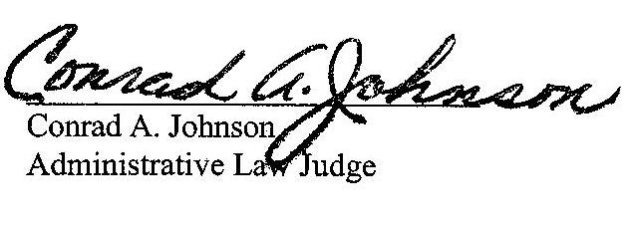
Dated: December 11, 2023

ATTACHMENT
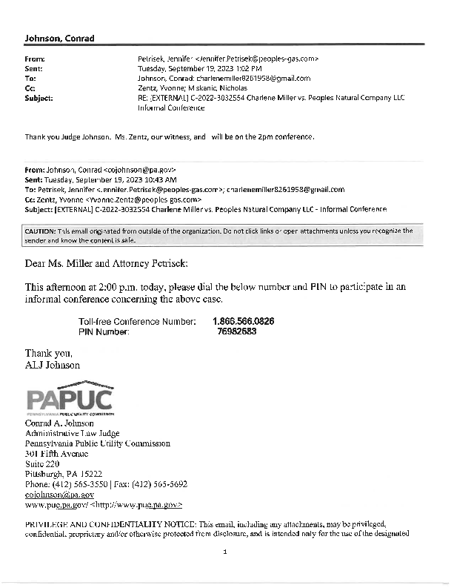
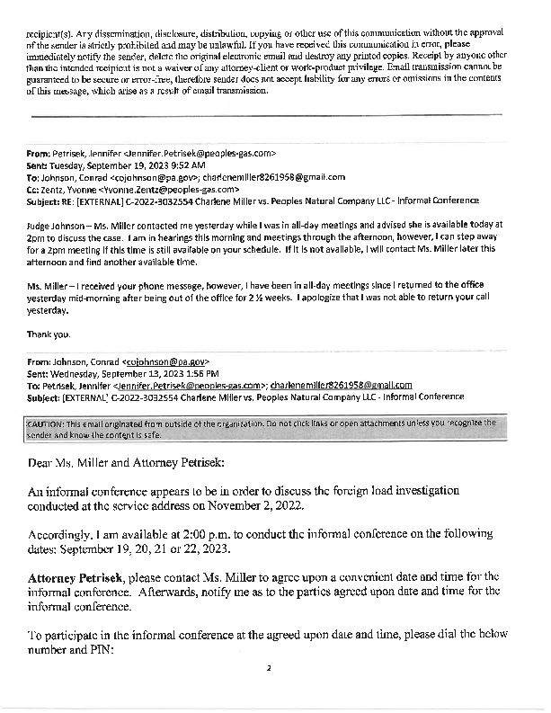
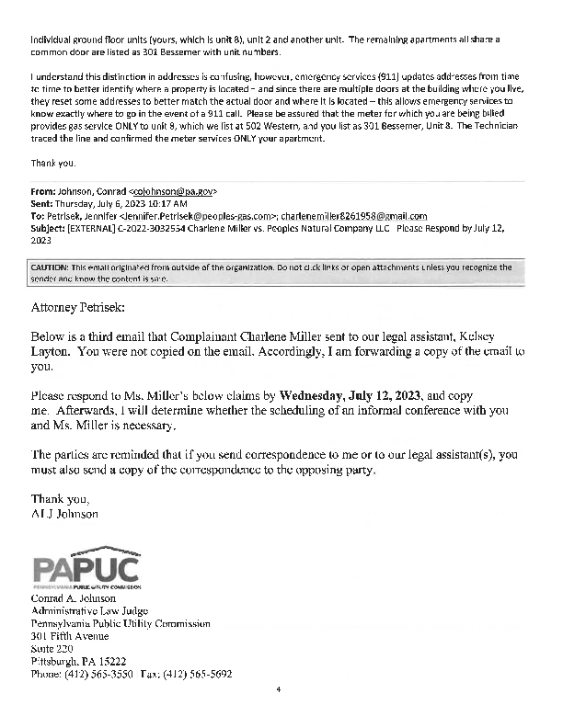

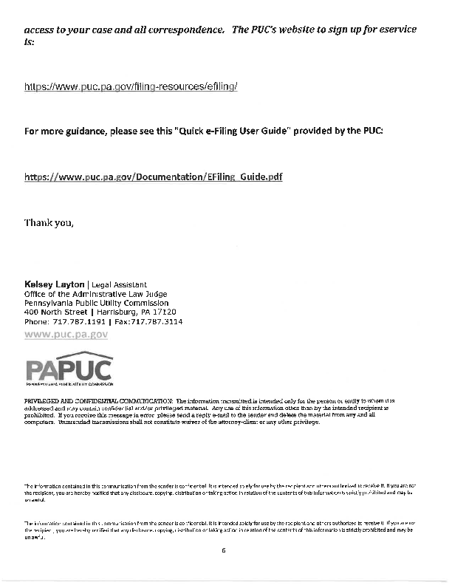
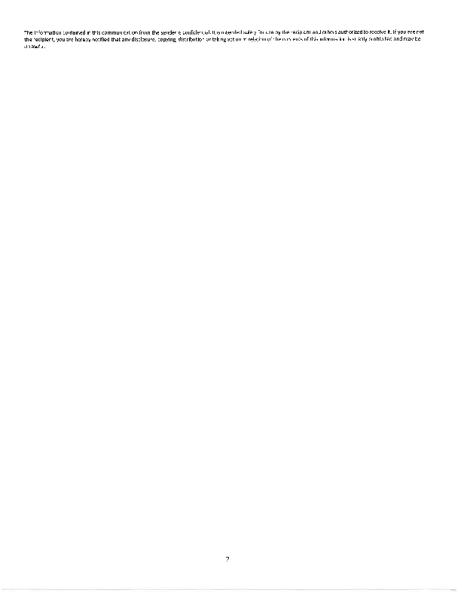

C-2022-3032554 - CHARLENE MILLER v. PEOPLES NATURAL GAS COMPANY
CHARLENE MILLER
301 BESSEMER AVE APT 8
EAST PITTSBURGH PA 15112
412.377.0271
charlenemiller8261958@gmail.com
JENNIFER L. PETRISEK ESQUIRE
375 NORTH SHORE DRIVE
PITTSBURGH PA 15212
412.208.6834
Jennifer.Petrisek@peoples-gas.com
Accepts eService
(Counsel for Peoples Natural Gas Company LLC)

