 | COMMONWEALTH OF PENNSYLVANIA  PENNSYLVANIA PUBLIC UTILITY COMMISSION  COMMONWEALTH KEYSTONE BUILDING  400 NORTH STREET  HARRISBURG, PENNSYLVANIA 17120 | IN REPLY PLEASE REFER TO OUR FILE

December 13, 2023
C-2018-3006031

Via E-mail: PARegulatoryComplaints@firstenergycorp.com
TORI GIESLER
FIRSTENERGY SERVICE COMPANY
2800 POTTSVILLE PIKE
READING PA 19605

Michael Jennings
v.
West Penn Power Company

Dear Ms. Giesler:

Attached is a copy of an amended complaint filed on behalf of the complainant in the above titled proceeding.

Such answer as you desire to make to the amended complaint should be filed in this Office and served upon the complainant within twenty days from receipt of this letter.

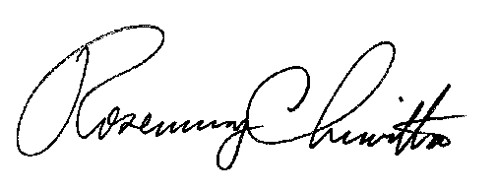
Very truly yours,

Rosemary Chiavetta
Secretary

RC:anc

