A-2023-3045018
Date Served: December 20, 2023

Caroline G. Robelen, Assistant Counsel,
Commonwealth of PA, Dept of Transportation,
Office of Chief Counsel,
PO Box 8212,
Harrisburg, PA 17105-8212
Email: crobelen@pa.gov

Application of the Department of Transportation of the Commonwealth of Pennsylvania for
approval to replace the existing bridge where State Route 2016 Bellevue Ave. crosses above the track(s) of Reading, Blue Mountain & Northern Railroad, DOT Number 592 475 A in Muhlenberg Township, Berks County and the allocation of costs incident thereto.

Dear Ms. Robelen:

Receipt is acknowledged of the application of Department of Transportation of the Commonwealth of Pennsylvania which has been captioned and docketed to the above number.

We note that you have served copies of the application upon the parties involved.

The matter will receive the Commission's attention, and you will be advised of any further procedure.

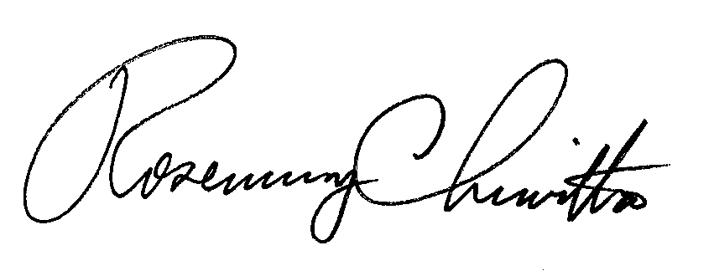
Sincerely,

Rosemary Chiavetta
Secretary

RC: JBS

