 | COMMONWEALTH OF PENNSYLVANIA  PENNSYLVANIA PUBLIC UTILITY COMMISSION  COMMONWEALTH KEYSTONE BUILDING  400 NORTH STREET  HARRISBURG, PENNSYLVANIA 17120 | IN REPLY PLEASE REFER TO OUR FILE

December 28, 2023

IN REPLY PLEASE
REFER TO OUR FILE

A-2023-3045014

Service by Email

COMCAST CABLE COMMUNICATIONS MANAGEMENT, LLC
ATTN: GENERAL COUNSEL
1701 JOHN F KENNEDY BOULEVARD
PHILADELPHIA, PA 19103
Email: Legal_Notices@comcast.com

Application of Comcast Cable Communications Management, LLC, for Approval of the Installation of New Overhead Communications Facilities at a Highway and Railroad Crossing of the National Railroad Passenger Corporation and Pennswood Road Located in Bryn Mawr, Lower Merion Township, Montgomery County, Pennsylvania.

Dear Sir/Madam:

Receipt is acknowledged of the application of Comcast Cable Communications Management, LLC., which has been captioned and docketed to the above number.

We note that you have served copies of the application upon the parties involved.

The matter will receive the Commission's attention, and you will be advised of any further procedure.

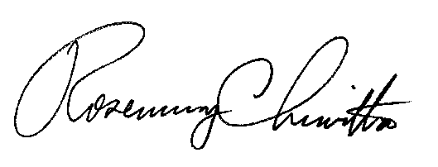
Very truly yours,

Rosemary Chiavetta
Secretary

RC:AEL

