 | COMMONWEALTH OF PENNSYLVANIA  PENNSYLVANIA PUBLIC UTILITY COMMISSION  COMMONWEALTH KEYSTONE BUILDING  Office of Administrative Law Judge  400 NORTH STREET  HARRISBURG, PENNSYLVANIA 17120

January 26, 2024

In Re: R-2023-3042804
R-2023-3042805

(SEE ATTACHED LIST)

Pennsylvania Public Utility Commission v. Community Utilities of Pennsylvania

1308 (d)

IN-PERSON EVIDENTIARY HEARINGS NOTICE

This is to inform you that hearings on the above-captioned case, for the purposes of receiving pre-served written testimony and the cross-examination of the Active Party Witnesses, will be held as follows:

Type: In-Person Evidentiary Hearings

Date: Thursday, March 28, 2024
Time: 10:00 A.M.

Date: Friday, March 29, 2024
Time: 10:00 A.M.

Date: Monday, April 1, 2024
Time: 10:00 A.M.

Location: Hearing Room 3
Plaza Level
Capitol Keystone Building
400 North Street
Harrisburg, PA, 17120

Presiding: Administrative Law Judge Steven K. Haas
Administrative Law Judge Alphonso Arnold III
Phone: 717.787.1399 Fax: 717.213.6812

WITNESSES MUST BE PRESENT AT THE TIME OF THE HEARING

FAILURE TO APPEAR: You may lose the case if you do not take part in this hearing and present evidence on the issue(s) raised. Your case may be dismissed “with prejudice” which means that you will be barred from filing another complaint raising the same claim(s) and issue(s) presented in the dismissed complaint.

REPRESENTATION. If you are an individual, you may represent yourself or you may have an attorney represent you. All others, including a partnership, corporation, trust, association, or governmental agency or subdivision, must be represented by an attorney licensed to practice law in Pennsylvania, or admitted pro hac vice. Only an attorney may represent someone else.

PRESENTING EXHIBITS. If you intend to present any documents or exhibits other than pre-served written testimony and exhibits at the hearing, you must email one (1) copy to the Presiding Officers at sthaas@pa.gov and alphonarno@pa.gov and one (1) copy each must be sent to every other party. All copies must be received at least five (5) business days before the hearing. Proposed exhibits should be properly pre-marked for identification purposes.

ACCOMMODATION. Any party who needs an accommodation for a disability in order
to participate in this hearing process may request one. Please call the OALJ scheduling office at least five (5) business days prior to your hearing to submit your request.

If you require an interpreter to participate in the session, we will make every reasonable effort to have an interpreter present. Please call the scheduling office at the Public Utility Commission at least ten (10) business days prior to the hearing to submit your request.

- Scheduling Office: (717) 787-1399
- Persons who are deaf or hearing-impaired may call a relay operator at 711.

E-FILING. The PUC offers a free e-Filing Subscription Service. This service allows a user to file documents electronically and receive an automatic email notification whenever a document is added, removed, or changed on the PUC website in a specific case. For information and to subscribe to this service, visit the PUC’s website at: http://www.puc.pa.gov/Documentation/eFiling_Subscriptions.pdf.

PAPER FILING. If you do not have the capability to open and use an e-Filing account, you may file paper documents with the Secretary of the Commission. Filing of paper documents must be sent by overnight delivery to:

Secretary
Pennsylvania Public Utility Commission
400 North Street
Harrisburg, PA 17120

It is important that you retain the tracking information as proof of submission.
Emailed or faxed submissions filings to the Commission are not acceptable.

CONFIDENTIAL MATERIAL. If a filing contains confidential or proprietary material, the filing should be submitted by overnight delivery to ensure arrival. Large filings containing confidential or proprietary material may also be submitted through the Commission’s Share Point File system. These filings should be followed by a hard copy with a flash drive or CD for the Commission’s file. Filers should contact the Secretary’s Bureau in advance to set up a Share Point File before submitting the filing.

cc: Calendar File, File Room

R-2023-3042804, R-2023-3042805 - PA PUBLIC UTILITY COMMISSION v. COMMUNITY UTILITIES OF PENNSYLVANIA INC – WATER AND WASTEWATER

WHITNEY E SNYDER ESQUIRE THOMAS J SNISCAK ESQUIRE
PHILLIP D DEMANCHICK ESQUIRE*
HAWKE MCKEON AND SNISCAK LLP
100 N Tenth Street
HARRISBURG PA 17101
717.236.1300
wesnyder@hmslegal.com
tjsniscak@hmslegal.com
pddemanchick@hmslegal.com
Accepts eService
*Served via email and first class mail

SCOTT B GRANGER ESQUIRE
BUREAU OF INVESTIGATION & ENFORCEMENT
SECOND FLOOR WEST
400 NORTH STREET
HARRISBURG PA 17120
717.425.7593
717.884.1440
sgranger@pa.gov
Accepts eService

HARRISON W BREITMAN ESQUIRE
JACOB GUTHRIE ESQUIRE
ERIN L GANNON ESQUIRE
OFFICE OF CONSUMER ADVOCATE
555 WALNUT STREET 5TH FLOOR
FORUM PLACE
HARRISBURG PA 17101
717.783.5048
hbreitman@paoca.org
jguthrie@paoca.org
egannon@paoca.org
Accepts eService
SHARON E WEBB ESQUIRE
OFFICE OF SMALL BUSINESS ADVOCATE
FORUM PLACE
555 WALNUT STREET 1ST FLOOR
HARRISBURG PA 17101
717.783.2525
717.783.2831
swebb@pa.gov
Served via email and first class mail
OLEG CHUCHIN
89 WEBSTER AVENUE
UNIT A
JERSEY CITY NJ 07307
201.873.7621
readypads@gmail.com
Accepts eService
CHRIST R NIELSEN
COMMUNITY UTILITIES OF PENNSYLVANIA
513 GANDOLF ROAD
TAMIMENT PA 18371
570.431.0727
239.222.1507
cnielsen4u@yahoo.com
Accepts eService
JOHN HOOPINGARNER
1110 LONG LAKE ROAD
TAMIMENT PA 18371
1.570.588.6496
jwhoop@ptd.net
Accepts eService

ROSE COCKLIN
2104 TAMIMENT LN
TAMIMENT PA 18371
347.204.9366
tintofrose@aol.com
Accepts eService
MICHAEL JOHN SANFILIPPO
503 DWALIN WAY
TAMIMENT PA 18371
973.508.5001
973.794.6666
michaeljsanfilippo@gmail.com
Accepts eService
RAFAIL KOVALENKO
2138 WILDERLAND ROAD
TAMIMENT PA 18371
718.637.4343
dmitrykov@outlook.com
Accepts eService
JENNY HOWARD
212 HOBBIT DR
TAMIMENT PA 18371
352.441.4881
djandjenny@gmail.com
Accepts eService

CHRISTINE CORBISSERO
221 RAVENHILL RD
TAMIMENT PA 18371
908.670.3333
turkeyhunter333@gmail.com
Accepts eService
SCOTT FUREY
212 RAVENHILL ROAD
TAMIMENT PA 18371
718.395.0350
furiousvicky1@aol.com
Accepts eService
CHRISTINA G BOERS
157 OAKENSHIELD DRIVE
TAMIMENT PA 18371
917.969.3129
christina.boers82@gmail.com
Accepts eService
GEORGE LINGG
417 UNDERHILL DRIVE
TAMIMENT PA 18371
703.901.2567
glingg52@gmail.com
Accepts eService
GREGORY LEONE
213 THISTLEBROOK COURT
TAMIMENT PA 18371
570.994.2800
gregleone@msn.com
Accepts eService
NATALIE ORTIZ
106 THORIN WAY
TAMIMENT PA 18371
570.588.6730
917.868.7349
natalie.e.ortiz@gmail.com
Accepts eService
CASSANDRA KRAMER
1321 STERLING DRIVE
EAST STROUDSBURG PA 18301
917.749.1977
cassierovitti@hotmail.com
Accepts eService
MONICA WAGNER
314 HYLAND DRIVE
EAST STROUDSBURG PA 18301
609.509.5506
monica.wagner4@gmail.com
Accepts eService
ERNESHA BOLDEN
119 SUNDEW DRIVE
EAST STROUDSBURG PA 18301
917.771.9584
ehollo3609@aol.com
Accepts eService
PETRICIA PERVILLE- DAVY
448 DEBORAH DR
EAST STROUDSBURG PA 18301
973.919.5629
Pp.perville@gmail.com
Accepts eService
NANETTE DE BARTOLO
1215 WOODLAND DRIVE
EAST STROUDSBURG PA 18301
570.259.5386
nanettedb1@gmail.com
Accepts eService
SUSAN J NIKOLAOU
111 TOMNODDY DRIVE
TAMIMENT PA 18371
973.461.6380
susankostelnik@hotmail.com
Accepts eService

BRIAN ANTHONY FENIMORE
1433 HENRY DRIVE
DOWNINGTOWN PA 19335
610.873.0581
717.329.9167
bfenimore10@comcast.net
Accepts eService

DAVE FARDIG
BUREAU OF LABS
1498 SAWMILL ROAD DOWNINGTOWN PA 19335
484.238.5071
dfardig@pa.gov
Accepts eService
LYNN BUCKINGHAM
981 BELLE AVEN
TEANECK NJ 07666
201.692.8282
lynn.buckingham@gmail.com
Accepts eService
DANIEL MCKOY
COMMUNITY UTILITIES OF PENNSYLVANIA
151 OAKENSHIELD DRIVE
TAMIMENT PA 18371
917.635.2418
917.635.2417
Lisabj115@gmail.com
Accepts eService
RENE BRESSANT
204 GOLLUM LANE
TAMIMENT PA 18371
347.213.9608
rbjrcd@gmail.com
Accepts eService

CHRISTOPHER WILLIAMS
1604 RUSSELL DR
DOWNINGTOWN PA 19335
484.437.3703
cwilliams10@gmail.com
Accepts eService

DENISE COOPER
109 THORIN WAY
TAMIMENT PA 18371
917.797.3827
hotspursproductions@gmail.com
Served via email and first class mail
RYAN ELLISON
167 OAKENSHIELD DRIVE
TAMIMENT PA 18371
646.796.9519
ellisonhomebuy@gmail.com
Served via email and first class mail
CRAIG MORRIS
4205 Woodacre's Drive
EAST STROUDSBURG PA 18301
570.460.2322
motorman_18301@yahoo.com
Accepts eService
ANNA MAJEWSKI
209 THISTLEBROOK COURT
TAMIMENT PA 18371
917.569.6799
kurzatharz1@yahoo.com
Served via email and first class mail
ANNA PARYZKI
212 GOLLUM LANE
TAMIMENT PA 18371
570.431.4988
862.221.5995
ppemail@msn.com
Served via email and first class mail

RICHARD AND SUSAN DIPIAZZA
215 WITHYWINDLE WAY
TAMIMENT PA 18371
570.588.1663
908.229.2105
impact451@hotmail.com
Served via email and first class mail

GRAZYNA PARYZKA
217 OAKENSHIELD DRIVE
TAMIMENT PA 18371
570.431.4604
862.221.0096
ppemail@msn.com
Served via email and first class mail

LARISA SHIN
507 GANDOLF RD
TAMIMENT PA 18371
646.897.5466
larisa_shin@yahoo.com
Served via email and first class mail

BRIAN MORRISON
500 KILLI WAY
TAMIMENT PA 18371
718.530.3257
BMorrison@me.com
Served via email and first class mail

JOSEPH BELLANTONI
425 UNDERHILL DRIVE
TAMIMENT PA 18371
917.696.5798
joebellan@earthlink.net
Served via email and first class mail

MAUREEN MADDEN
NORTHEAST DELEGATION
325 MAIN CAPITOL BLD
PO BOX 202115
HARRISBURG PA 17120-2115
717.787.5811
Served via first class mail





- Click on PUC hyperlink provided in email

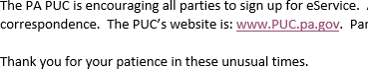

- Click on “Filing & Resources” tab at the top


- Click on “eFiling” under “Filing and/or Obtaining Information”
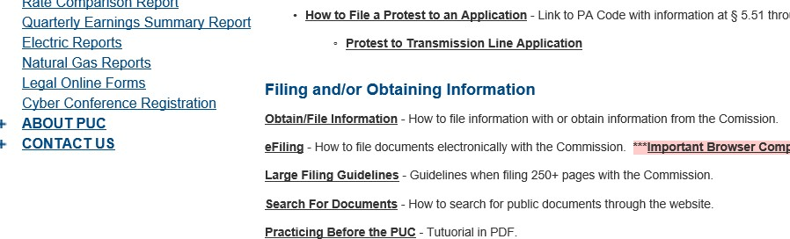

- Click on “individual account” hyperlink
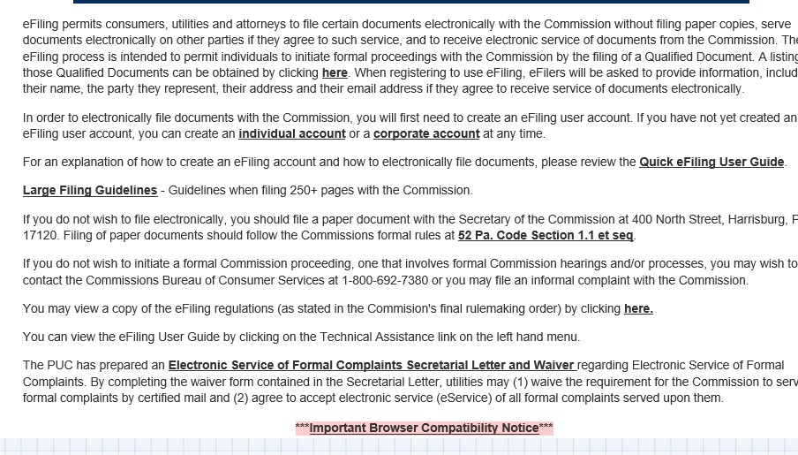
- Fill out entire form
