 | COMMONWEALTH OF PENNSYLVANIA  PENNSYLVANIA PUBLIC UTILITY COMMISSION  COMMONWEALTH KEYSTONE BUILDING  400 NORTH STREET  HARRISBURG, PENNSYLVANIA 17120 | IN REPLY PLEASE REFER TO OUR FILE

February 27, 2024

A-2023-3041145

Served by Email

FELLER LAW GROUP, PLLC
ATTN: MICHELLE MANN, DIRECTOR OF GOVERNMENT AFFAIRS & REGULATORY COMPLIANCE
159 20TH STREET, SUITE 1B
BROOKLYN, NY 11232
Email: michellemann@feller.law

Dear Ms. Mann:

On February 22, 2024, the Commission received your filing deemed Name/Entity Change Request from Energy Zebra LLC to American Electric Rates LLC. It has been determined your filing is deficient for the following reason:

The required $350.00 filing fee is missing.

Please be advised that you are directed to forward the requested information to the Commission within 20 days from the date of this letter. Failure to respond may cause Commission staff to initiate a formal proceeding that may lead to cancellation of Energy Zebra LLC’s natural gas supplier license, fines and penalties, removal of the company’s information from the Commission’s website, and notification to all gas distribution companies in which Energy Zebra LLC is licensed to do business.

Should you have any questions please contact our Bureau at 717-772-7777.

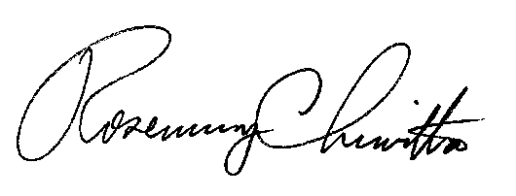
Sincerely,

Rosemary Chiavetta
Secretary

RC: AEL

cc: File Room
Technical Utility Services

