PENNSYLVANIA PUBLIC UTILITY COMMISSION
NOTICE TO BE PUBLISHED

Petition of PPL Electric Utilities Corporation for Approval of a Default Service Program and Procurement Plan for the Period from June 1, 2025 through May 31, 2029 (DSP VI Program).
Docket Number: P-2024-3047290
___________________________________________________

Formal Protests, Petitions to Intervene and Answers must be filed in
Accordance with Title 52 of the Pennsylvania Code on or before
April 19, 2024. All filings must be made with the Secretary of the
Pennsylvania Public Utility Commission, 400 North Street, Harrisburg, PA 17120, with a copy served on the Petitioner and a copy provided to the Administrative Law Judge.

The documents filed in support of the Petition are available for inspection and copying at the Office of the Secretary between the hours of 8:00 a.m. and 4:30 p.m., Monday through Friday, and at the Petitioner’s business address.

Applicant:
PPL Electric Utilities Corporation
Through and by Counsel:
Kimberly A. Klock, Esquire
Michael J. Shafer, Esquire
PPL Services Corporation
Two North Ninth Street
Allentown, PA 18101

Telephonic Prehearing Conference
An initial telephonic prehearing conference on the above-captioned case will be held as follows:
Date: | Friday, April 26, 2024
Time: | 10:00 a.m.
Presiding: | Administrative Law Judge F. Joseph Brady  Suite 4063  801 Market Street  Philadelphia, PA 19107  215.560.2105  Fax: 717.231.4764

To participate in the conference,

- You must dial the toll-free bridge number listed below
- You must enter a PIN number when instructed to do so, also listed below
- You must speak your name when prompted
- The telephone system will connect you to the conference

Toll-free Bridge Number: 1.877.874.1047
PIN Number: 11738422

Individuals representing themselves are not required to be represented by an attorney. All others (corporation, partnership, association, trust or governmental agency or subdivision) must be represented by an attorney. An attorney representing you should file a Notice of Appearance before the scheduled hearing date.

If you require an interpreter to participate in the hearings, we will make every reasonable effort to have an interpreter present. Please email Pam McNeal, Legal Assistant, at pmcneal@pa.gov or call the regional office at 215.560.3133. The request should be received at least five (5) business days prior to the hearing to ensure one is available.

Persons who are deaf or hearing-impaired dial 717 to reach a relay operator.

The Public Utility Commission offers a free e-Filing Subscription Service, which allows users to automatically receive an email notification whenever a document is added, removed, or changed on the PUC website regarding a specific case. Instructions for subscribing to this service are on the PUC’s website at http://www.puc.pa.gov/Documentation/eFiling_Subscriptions.pdf.

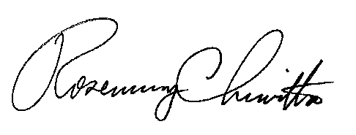
BY THE COMMISSION

Rosemary Chiavetta
Secretary

