 | COMMONWEALTH OF PENNSYLVANIA  PENNSYLVANIA PUBLIC UTILITY COMMISSION  COMMONWEALTH KEYSTONE BUILDING  400 NORTH STREET  HARRISBURG, PENNSYLVANIA 17120 | IN REPLY PLEASE REFER TO OUR FILE

March 28, 2024

Via E-mail: glent@postschell.com Docket Number: A-2024-3047924
GARRETT LENT
POST & SCHELL PC
17 NORTH 2ND ST 12TH FL
HARRISBURG PA 17101

Dear Mr. Lent:

Receipt is acknowledged of the Letter of Notification of PPL Electric Utilities Corporation which has been processed to the above captioned docket number.

This matter will receive the attention of the Commission and you will be advised of any further necessary procedure.

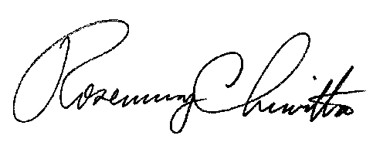
Sincerely,



Rosemary Chiavetta
Secretary

RC:anc

