 | COMMONWEALTH OF PENNSYLVANIA  PENNSYLVANIA PUBLIC UTILITY COMMISSION  COMMONWEALTH KEYSTONE BUILDING  400 NORTH STREET  HARRISBURG, PENNSYLVANIA 17120 | IN REPLY PLEASE REFER TO OUR FILE

July 2, 2024

C-2024-3047348
RIVERFRONT MOVING & STORAGE, LLC
ATTN: DANTE REEVES
2742 KIGHTS RD
BENSALEM PA 19020

Dear Sir or Madam:

On June 20, 2024, the Commission received your fine payment of $750.00.

We are returning your check (no. 2161) in the amount of $750.00 to you because we are not permitted to accept company checks. All filing fees and fines must be submitted in the form of a certified check or money order or check from your attorney made payable to the Commonwealth of Pennsylvania.
Please return your corrected fine payment to the above listed address and address to the attention of Secretary Chiavetta.

Should you have any questions pertaining to this letter, please contact our Bureau at 717-772-7777.

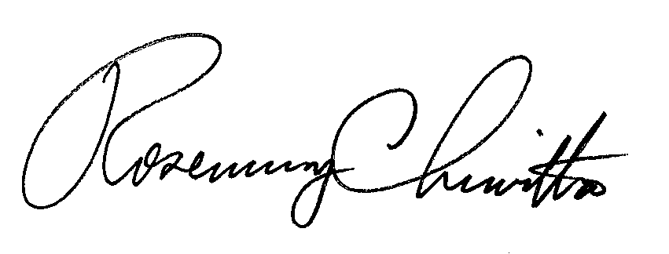

Sincerely,

Rosemary Chiavetta Secretary

Enclosed: $750 Company Check # 2161
RC:mm

