PENNSYLVANIA PUBLIC UTILITY COMMISSION

Public Meeting held August 1, 2024
Docket Number: M-2024-3049527

BUREAU OF TECHNICAL UTILITY SERVICES

REPORT ON THE QUARTERLY EARNINGS

OF JURISDICTIONAL UTILITIES

FOR THE YEAR ENDED

March 31, 2024

Stephen M. DeFrank, Chairman
Kimberly Barrow, Vice Chair
Ralph V. Yanora
Kathryn L. Zerfuss
John F. Coleman, Jr.

TABLE OF CONTENTS
Page No.

Introduction..................................................................................................... 4

Attachment A – Summary of Equity Returns……………………………… 5

Attachment B – Summary of Returns 12
This chart depicts the overall and equity returns (actual and adjusted) for the filing utilities for the current quarter. The last authorized equity returns and the year authorized is also shown.

Attachment C – Allowed Rates of Return on Common Equity 14
This is a historical chart that shows the most recent rate cases for select companies in electric, gas, and water. A docket number followed by their final return on equity and year is also given.

Attachment D – Distribution System Improvement Charge Return on Equity 15
Compares utility adjusted return on equity to Commission authorized return on equity for utilities with a Distribution System Improvement Charge.

Attachment E – Explanation of Return on Equity Methods 16
Criteria for determining the industry barometer groups used in ROE calculations. Also, provides details of the Discounted Cash Flow equation and Capital Asset Pricing Model equation.

Attachment F – Market Based Returns on Equity – Electric 18
The market indicated common equity cost rate range consists of data used from the electric barometer groups and is based on a series of calculations to average the DCF methods. Also, indicates Distribution System Improvement Charge Return.

Attachment F – Historic DCF and CAPM – Electric 19
Historic barometer group DCF and CAPM average ROEs.

Attachment F – Electric Barometer Group Calculation of a Current and 52 Week Average Dividend Yield 20-21
Electric barometer companies are used to calculate a current DCF in the first chart. The second chart demonstrates the companies 52-week average DCF. A final average of the two calculations is also shown at the bottom.

Attachment F – Development of a Representative Dividend Growth Rate…………………………………………………... 22
Multiple sources of the gas barometer companies projected 5-year Earnings Per Share are used to calculate the Group Average Dividend Growth Estimate.

Attachment G – Market Based Returns on Equity – Gas 23
The market indicated common equity cost rate range consists of data used from the gas barometer groups and is based on a series of calculations to average the DCF methods. Also, indicates Distribution System Improvement Charge Return.

Attachment G – Historic DCF and CAPM – Gas 24
Historic barometer group DCF and CAPM average ROEs, including a linear trend line graph.

Attachment G – Gas Barometer Group Calculation of a Current and 52 Week Average Dividend Yield 25
Gas barometer companies are used to calculate a current DCF in the first chart. The second chart demonstrates the companies 52-week average DCF. A final average of the two calculations is also shown at the bottom.

Attachment G – Development of a Representative Dividend Growth Rate…………………………………………………... 26
Multiple sources of the gas barometer companies projected 5-year Earnings Per Share are used to calculate the Group Average Dividend Growth Estimate.

Attachment H – Market Based Returns on Equity – Water 27
The market indicated common equity cost rate range consists of data used from the water barometer groups and is based on a series of calculations to average the DCF methods. Also, indicates Distribution System Improvement Charge Return.

Attachment H – Historic DCF and CAPM – Water 28
Historic barometer group DCF and CAPM average ROEs, including a linear trend line graph.

Attachment H – Water Barometer Group Calculation of a Current and 52 Week Average Dividend Yield 29
Water barometer companies are used to calculate a current DCF in the first chart. The second chart demonstrates the companies 52-week average DCF. A final average of the two calculations is also shown at the bottom.

Attachment H – Development of a Representative Dividend Growth Rate…………………………………………………... 30
Multiple sources of the water barometer companies projected 5-year Earnings Per Share are used to calculate the Group Average Dividend Growth Estimate.

Introduction:

On September 20, 1991, the Commission initiated a rulemaking at L-00910061 pertaining to earnings disclosures by the public utilities subject to its jurisdiction. At that docket, the Commission stated that the submission of accurate, reliable, and complete earnings disclosure reports, at regular intervals, is essential to the fulfillment of the broad regulatory oversight responsibilities entrusted to the Commission by the Legislature in the Public Utility Code. The earnings disclosure regulations promulgated by the Commission were adopted October 1, 1992, and published January 23, 1993, at 23 Pa.B. 463. Based upon those regulations, codified at 52 Pa. Code, Chapter 71, a reporting format was developed and distributed to the jurisdictional fixed utilities of Pennsylvania.

All fixed utilities having jurisdictional revenues of $1,000,000 or more, for a calendar year, are required to file the report by March 31 of each year. Such reports are to be based upon the results of operations for the 12-month period ending December 31 of the prior year. Utilities having more than $10,000,000 in jurisdictional revenues are also required to file reports for the 12 months ending on March 31, June 30, and September 30 of each year. On November 30, 2004, however, the Pennsylvania General Assembly signed into law Act 183 concerning alternative telecommunications regulation and broadband deployment. As a result of Act 183, the reporting requirements for the PUC jurisdictional telecommunications companies of Pennsylvania have been streamlined at section 3015(e) of the Public Utility Code. A quarterly earnings report is not listed among those reports now required of PUC jurisdictional telecommunications utilities in Pennsylvania and, therefore, this report does not address telephone company earnings.

The reports have been filed for the period ended March 31, 2024. The Finance Staff of the Bureau of Technical Utility Services has reviewed the reports and has prepared this summary report for public release. This report sets forth the achieved return on equity for each company, the last allowed return for that utility, a market return as determined through the analysis of the barometer group data and the most recent returns allowed, per industry, by the Pennsylvania Public Utility Commission and by other regulatory bodies. Where a utility has not filed a report, the reasons for not filing are indicated.

Questions pertaining to the preparation and contents of this Report should be directed to Ms. Erin Laudenslager, Manager - Finance, Bureau of Technical Utility Services, at (717) 705-4364.

The equity return summaries that follow in Attachment A are, for each quarter;

ACTUAL
- Based on actual results of operations

and

ADJUSTED
2. Based on company proposed pro forma and ratemaking adjustments

ELECTRIC UTILITIES
EQUITY RETURNS BY QUARTER
QTR  END |  | Peco |  | PPL |  | Duq |  | W Penn |  | PaPwr |  | UGI |  | Penelec |  | MetEd
 |  | ACT | ADJ | ACT | ADJ | ACT | ADJ | ACT | ADJ | ACT | ADJ | ACT | ADJ | ACT | ADJ | ACT | ADJ
2018 | 1 |  |  | 12.53 | 11.36 |  |  | 10.35 | 9.08 | 9.03 | 8.08 |  |  | 11.84 | 9.93 | 12.77 | 11.38
 | 2 |  |  | 11.05 | 9.49 |  |  | 9.92 | 8.52 | 8.79 | 7.57 |  |  | 11.56 | 9.39 | 11.90 | 10.26
 | 3 |  |  | 11.19 | 9.83 |  |  | 11.41 | 6.74 | 10.30 | 5.80 |  |  | 13.97 | 8.44 | 14.46 | 9.62
 | 4 | 10.88 | 7.61 | 11.10 | 10.15 | 12.06 | 9.39 | 9.92 | 6.78 | 10.64 | 7.43 |  |  | 13.27 | 9.31 | 13.05 | 7.40
2019 | 1 | 12.65 | 7.93 | 10.10 | 8.96 | 12.58 | 9.73 | 9.08 | 6.62 | 9.14 | 7.61 | 7.05 | 5.22 | 12.03 | 8.07 | 12.54 | 7.66
 | 2  3 | 12.34  12.49 | 7.94  7.96 | 10.51  10.61 | 8.95  8.99 | 12.38  13.88 | 9.34  9.33 | 8.02  9.90 | 5.99  7.87 | 8.29  9.28 | 7.10  7.76 | 5.77  6.20 | 3.22  2.04 | 11.42  11.26 | 8.16  8.78 | 11.72  12.25 | 7.21  7.77
 | 4 | 12.21 | 8.50 | 10.53 | 10.40 | 13.92 | 9.08 | 14.13 | 7.07 | 8.08 | 6.90 | 7.20 | 2.38 | 10.02 | 8.54 | 10.96 | 9.27
2020 | 1 | 11.31 | 8.35 | 10.84 | 11.20 | 12.66 | 8.31 | 9.82 | 5.54 | 5.06 | 6.71 | 5.43 | 2.26 | 7.24 | 8.74 | 7.20 | 8.31
 | 2 | 9.38 | 8.17 | 11.20 | 10.81 | 12.73 | 8.56 | 10.41 | 5.53 | 5.56 | 6.55 | 6.06 | 2.01 | 6.68 | 7.94 | 7.34 | 8.04
 | 3 | 9.62 | 8.56 | 11.14 | 11.20 | 12.32 | 8.08 | 10.22 | 5.42 | 5.62 | 6.74 | 7.76 | 0.41 | 7.87 | 8.75 | 7.64 | 8.37
 | 4 | 9.16 | 7.64 | 11.10 | 11.48 | 12.57 | 8.15 | 7.48 | 5.65 | 11.36 | 7.34 |  |  | 10.08 | 8.62 | 9.91 | 8.64
2021 | 1 |  |  | 11.03 | 11.76 |  |  | 10.89 | 6.64 | 12.01 | 7.01 |  |  | 13.27 | 8.96 | 14.19 | 9.44
 | 2 |  |  | 11.17 | 11.73 |  |  | 11.42 | 7.07 | 11.27 | 5.94 |  |  | 13.23 | 8.15 | 14.13 | 9.06
 | 3 |  |  | 10.57 | 10.65 |  |  | 12.08 | 7.91 | 11.27 | 5.91 |  |  | 13.85 | 8.67 | 14.29 | 9.38
 | 4 | 9.79 | 7.59 | 9.69 | 10.57 | 11.37 | 11.23 | 13.57 | 7.85 | 12.21 | 5.42 |  |  | 17.25 | 8.04 | 16.74 | 9.40
2022 | 1 | 9.98 | 6.99 | 9.55 | 9.49 | 12.71 | 10.91 | 12.40 | 6.99 | 12.26 | 5.30 | 5.03 | 4.93 | 17.35 | 7.83 | 16.48 | 9.40
 | 2 | 10.32 | 7.19 | 9.33 | 9.54 | 12.51 | 10.22 | 10.70 | 5.78 | 11.69 | 5.04 | 5.01 | 3.89 | 15.95 | 6.93 | 15.59 | 8.72
 | 3 | 12.17 | 7.42 | 8.97 | 9.14 | 12.52 | 9.74 | 9.21 | 4.43 | 9.23 | 4.35 | 5.58 | 0.65 | 14.87 | 5.88 | 14.70 | 7.57
 | 4 | 11.48 | 6.59 | 9.41 | 9.18 | 12.62 | 9.54 | 8.89 | 4.19 | 7.03 | 3.44 |  |  | 10.16 | 5.07 | 11.56 | 7.55
2023 | 1 | 10.80 | 6.47 | 9.76 | 9.36 | 11.63 | 9.53 | 8.89 | 5.32 | 6.11 | 4.01 |  |  | 11.15 | 6.88 | 10.77 | 8.25
 | 2 | 10.24 | 6.19 | 9.43 | 8.67 | 10.69 | 9.39 | 9.49 | 6.03 | 7.45 | 5.58 |  |  | 12.20 | 7.90 | 11.14 | 8.81
 | 3 | 8.30 | 5.48 | 9.72 | 8.12 | 10.12 | 8.89 | 9.09 | 5.96 | 7.50 | 5.76 |  |  | 11.84 | 7.79 | 10.54 | 8.60
 | 4 | 8.60 | 5.19 | 9.84 | 8.49 |  |  | 7.47 | 6.02 | 10.49 | 7.09 | 3.36 | 4.48 | 11.03 | 8.17 | 9.61 | 8.66
2024 | 1 |  |  | 9.63 | 8.22 |  |  |  |  |  |  | 5.70 | 2.03
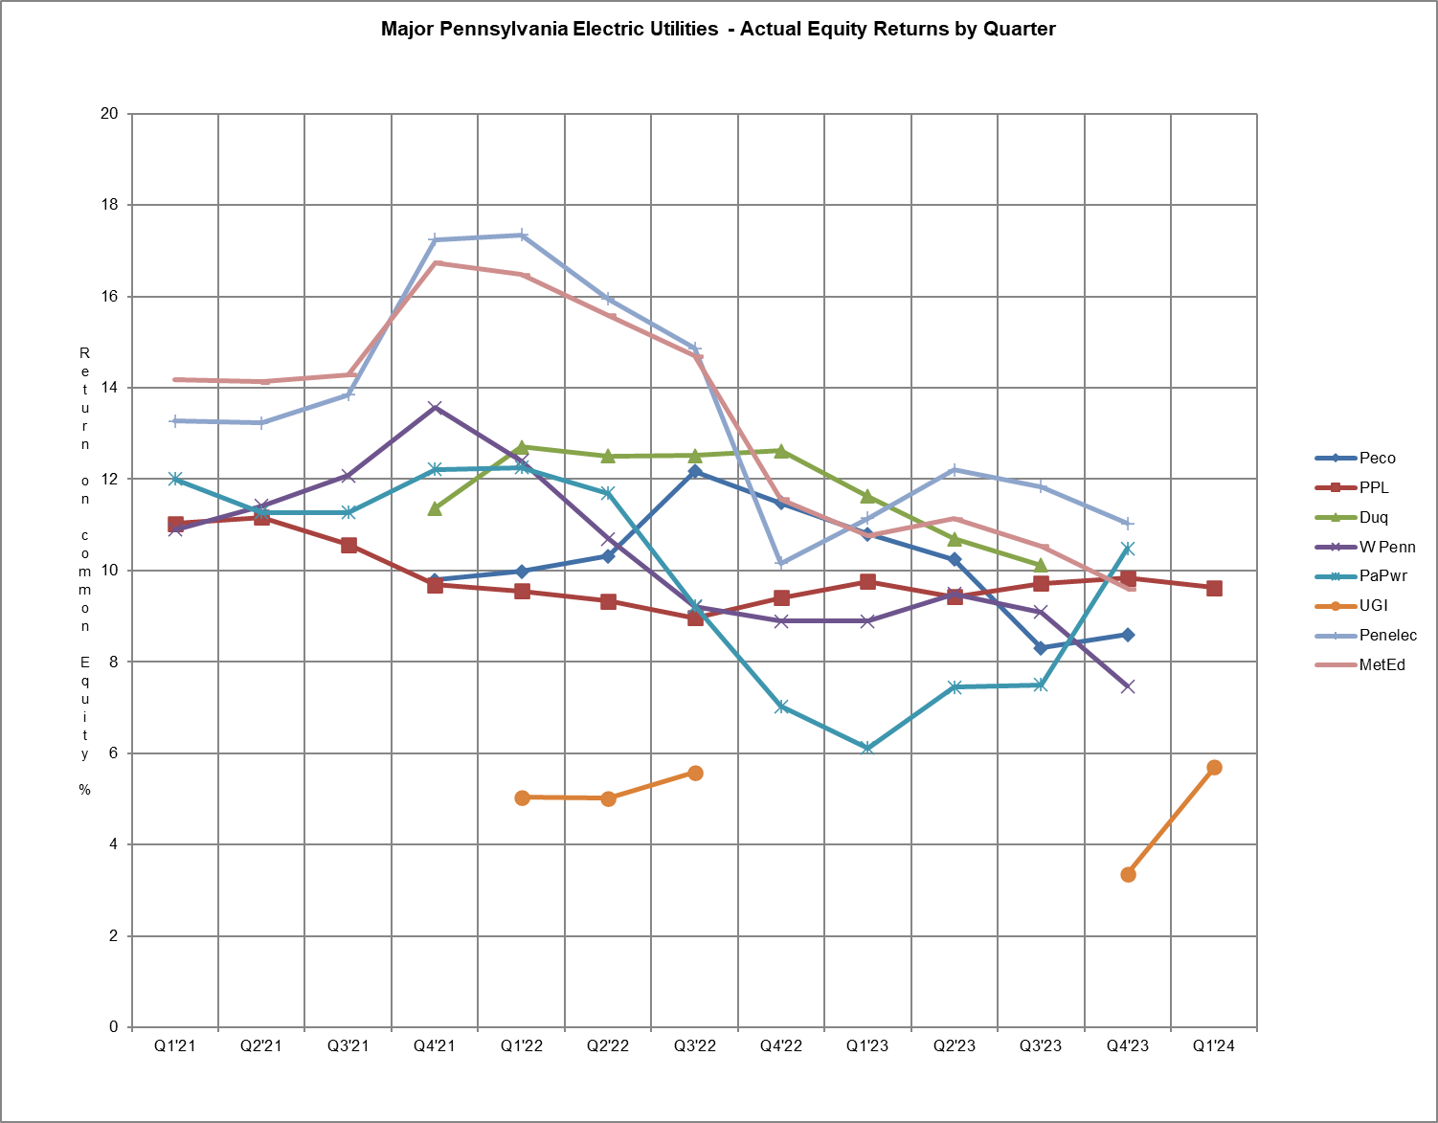
GAS UTILITIES
EQUITY RETURNS BY QUARTER

QTR |  |  | Columbia |  | Peoples Natural |  | PECO |  | NFG |  | UGI |  | Peoples  Gas
END |  |  | ACT | ADJ | ACT | ADJ | ACT | ADJ | ACT | ADJ | ACT | ADJ | ACT | ADJ
2018 | 1 |  |  |  | 11.42 | 7.00 | 12.65 | 9.77 | 14.40 | 10.20 | 12.82 | 7.90 | 14.02 | 10.17
 | 2 |  |  |  | 11.03 | 6.80 | 12.66 | 9.05 | 12.06 | 9.89 | 16.75 | 6.80 | 12.78 | 10.15
 | 3 |  |  |  | 10.21 | 7.43 | 12.54 | 8.36 | 12.52 | 10.12 | 18.69 | 8.04 | 13.03 | 10.20
 | 4 |  | 11.39 | 9.81 |  |  | 12.86 | 8.68 | 12.24 | 10.21 |  |  | 13.92 | 11.13
2019 | 1 |  | 12.76 | 10.22 |  |  | 13.68 | 9.06 | 11.83 | 10.93 |  |  | 14.10 | 10.71
 | 2  3 |  | 12.04  11.77 | 9.92  9.85 |  |  | 12.62  12.40 | 8.41  8.31 | 14.56  14.17 | 9.99  9.75 |  |  | 13.80  14.02 | 11.66  11.63
 | 4 |  | 9.21 | 9.09 | 10.74 | 12.26 | 11.75 | 6.99 | 14.20 | 9.77 |  |  | 12.76 | 11.20
2020 | 1 |  | 8.42 | 9.11 | 12.34 | 12.34 | 10.84 | 7.68 | 11.82 | 9.92 |  |  | 11.40 | 11.07
 | 2 |  |  |  | 13.81 | 12.38 | 11.26 | 7.25 | 11.28 | 9.05 |  |  | 11.89 | 11.10
 | 3 |  |  |  | 14.60 | 12.77 |  |  | 10.39 | 8.25 |  |  | 11.82 | 11.50
 | 4 |  |  |  | 12.09 | 10.37 |  |  | 9.68 | 8.12 |  |  | 12.93 | 12.11
2021 | 1 |  |  |  | 12.69 | 10.43 |  |  | 10.27 | 8.47 | 11.22 | 7.70 | 12.69 | 11.76
 | 2 |  |  |  | 12.31 | 10.23 | 8.85 | 5.13 | 10.02 | 8.47 | 11.57 | 8.04 | 11.20 | 11.61
 | 3 |  |  |  | 11.97 | 10.27 | 9.16 | 5.27 | 9.64 | 8.45 | 11.24 | 6.97 | 10.56 | 11.38
 | 4 |  |  |  | 14.62 | 10.52 | 8.86 | 5.79 | 17.54 | 8.02 |  |  | 10.84 | 10.28
2022 | 1 |  |  |  | 15.71 | 10.93 |  |  | 19.24 | 7.88 |  |  | 11.83 | 12.09
 | 2 |  |  |  | 14.09 | 11.67 |  |  | 19.36 | 6.87 |  |  | 11.40 | 12.19
 | 3 |  |  |  | 13.13 | 10.30 |  |  |  |  |  |  | 13.08 | 11.31
 | 4 |  |  |  | 13.87 | 10.56 | 9.43 | 5.93 |  |  | 12.42 | 7.62 | 14.01 | 14.19
2023 | 1 |  | 10.75 | 10.30 | 11.50 | 9.02 | 8.29 | 6.05 |  |  | 13.45 | 8.33 | 13.61 | 12.68
 | 2 |  | 10.68 | 10.33 | 9.85 | 9.50 | 8.50 | 6.20 | 5.80 | 9.98 | 12.94 | 8.97 | 12.12 | 13.84
 | 3 |  | 10.19 | 10.72 | 9.28 | 8.17 | 8.41 | 6.01 | 7.29 | 9.58 | 11.43 | 8.27 | 11.17 | 14.22
 | 4 |  |  |  |  |  | 8.75 | 6.82 | 9.87 | 10.80 | 12.19 | 7.44
2024 | 1 |  | 8.67 | 9.61 |  |  |  |  | 16.10 | 10.64 | 12.39 | 7.55

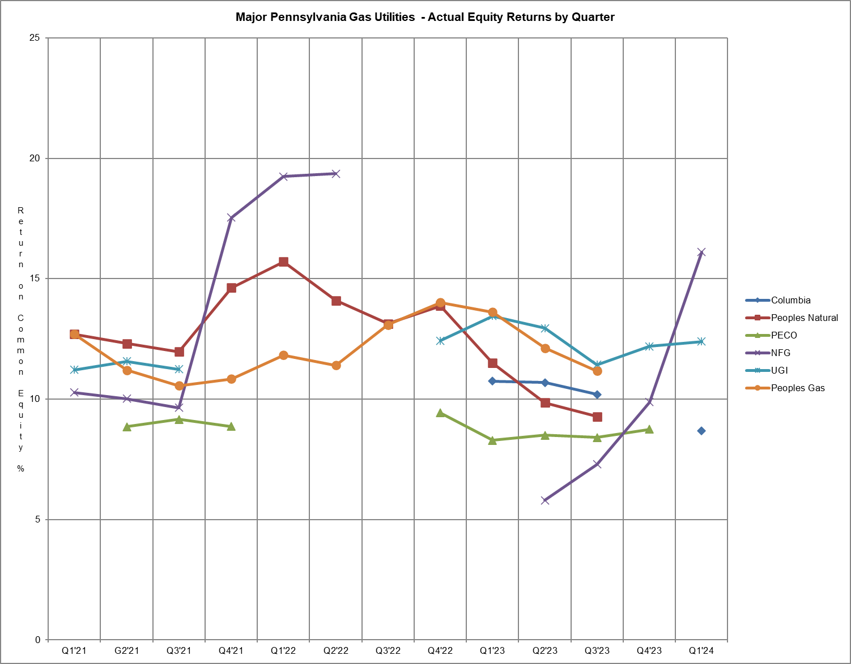

WATER UTILITIES
EQUITY RETURNS BY QUARTER

QTR |  | PAWC |  | Aqua |  | Veolia |  | York
END |  | ACT | ADJ | ACT | ADJ | ACT | ADJ | ACT | ADJ
2018 | 1 | 9.55 | 8.97 | 10.94 | 8.41
 | 2 | 10.27 | 9.65
 | 3 | 11.03 | 9.48
 | 4 | 10.08 | 9.03 |  |  |  |  | 10.70 | 10.30
2019 | 1 | 9.82 | 8.87 |  |  |  |  | 11.60 | 11.60
 | 2  3 | 9.72  9.13 | 8.90  8.41 | 9.84  10.69 | 9.04  8.84 | 10.78  11.55 | 10.36  11.75 | 11.80  12.00 | 11.80  12.00
 | 4 | 8.71 | 8.09 | 10.33 | 8.24 | 11.80 | 12.15 | 12.00 | 9.80
2020 | 1 | 8.74 | 7.56 | 10.47 | 8.31 | 11.30 | 11.30 | 12.39 | 12.39
 | 2 |  |  | 10.81 | 8.57 | 10.72 | 10.69 | 12.51 | 12.51
 | 3 |  |  | 10.33 | 8.55 | 11.13 | 10.69 | 13.76 | 13.76
 | 4 | 8.90 | 8.15 | 9.89 | 8.30 | 13.98 | 10.17 | 13.42 | 9.94
2021 | 1 | 9.41 | 8.90 | 9.99 | 8.38 | 14.34 | 10.48 | 12.98 | 9.74
 | 2 | 10.03 | 9.28 |  |  | 13.43 | 9.83 | 12.76 | 9.66
 | 3 | 9.89 | 8.65 |  |  | 13.58 | 9.07 | 12.51 | 9.32
 | 4 | 9.75 | 8.05 |  |  | 11.08 | 9.75 | 12.05 | 8.86
2022 | 1 | 9.73 | 7.82 |  |  | 12.04 | 9.68
 | 2 |  |  | 8.26 | 8.91 | 12.05 | 9.79
 | 3 |  |  | 8.78 | 8.85 | 11.14 | 9.30
 | 4 | 8.85 | 8.97 | 9.04 | 8.88 | 12.77 | 9.49 | 10.47 | 10.57
2023 | 1 | 8.86 | 8.90 | 9.42 | 8.48 | 11.53 | 8.98 | 11.12 | 11.12
 | 2 | 9.35 | 8.89 | 9.80 | 8.52 | 11.50 | 8.91 | 11.69 | 11.69
 | 3 | 9.84 | 8.93 | 9.74 | 8.39 | 10.72 | 8.42 | 12.23 | 12.23
 | 4 |  |  | 9.84 | 8.35 | 10.38 | 7.64 | 12.12 | 8.16
2024 | 1 |  |  |  |  | 8.28 | 6.49 | 10.46 | 7.99
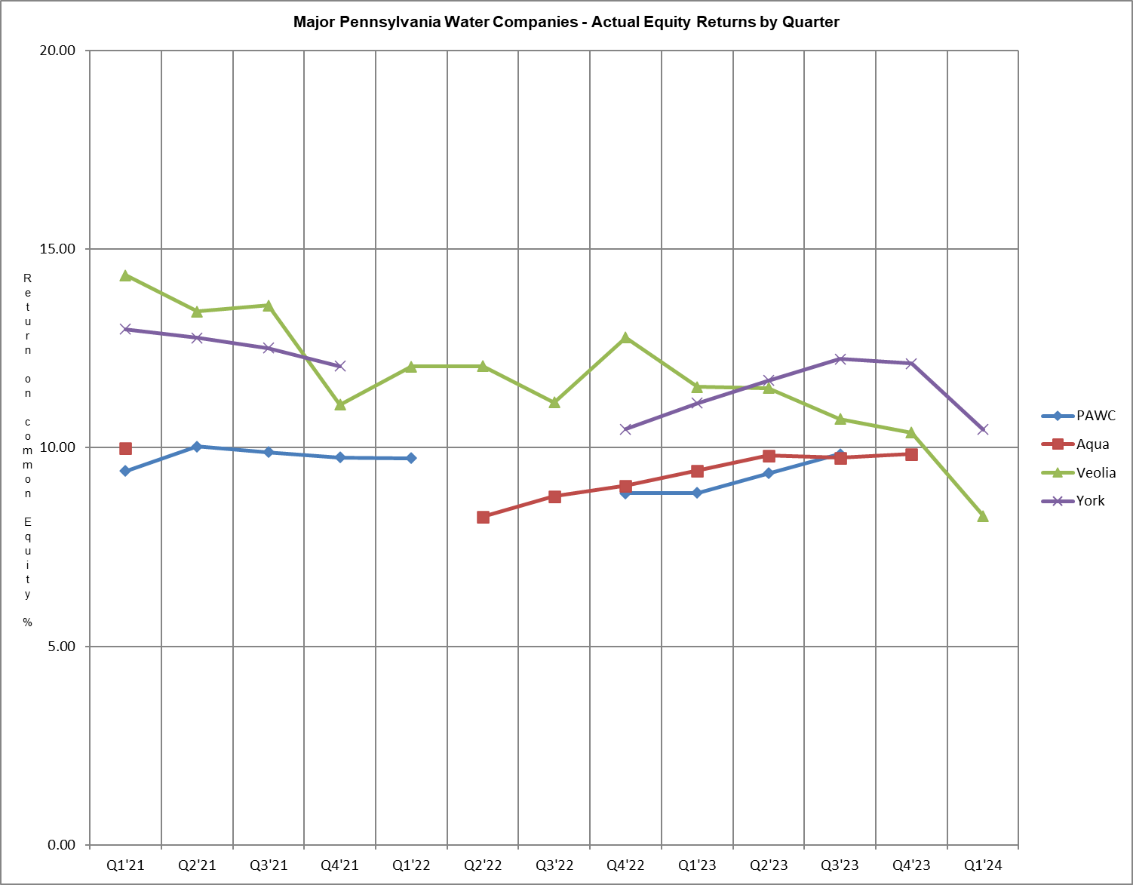

Attachment B includes:

A. Overall Returns on rate base
1. Actual
2. Company proposed pro forma and ratemaking adjustments

and

B. Equity Returns
1. Actual
2. Company proposed pro forma and ratemaking adjustments

Summary of Returns
For the Year Ended March 31, 2024
 | OVERALL RETURN |  | EQUITY RETURN |  | ROE | YEAR
COMPANY NAME | ACTUAL | ADJ | ACTUAL | ADJ | AUTH | AUTH
ELECTRIC
$10,000,000 Revenues
PECO Energy - Electric Operations* |  |  |  |  | Settled | 2021
PPL Electric Utilities Corp. | 7.49 | 6.66 | 9.63 | 8.22 | Settled | 2015
Duquesne Light Company* |  |  |  |  | Settled | 2021
West Penn Power Company* |  |  |  |  | Settled | 2017
Pennsylvania Power Company* |  |  |  |  | Settled | 2017
UGI Utilities, Inc. - Electric Division | 5.20 | 3.64 | 5.70 | 2.03 | Settled | 2023
Pennsylvania Electric Company* |  |  |  |  | Settled | 2017
Metropolitan Edison Company * |  |  |  |  | Settled | 2017
Over $1,000,000
Revenues
Pike County Light & Power Co. | 7.18 | 7.18 | 9.25 | 9.25 | Settled | 2021
GAS
$10,000,000 Revenues
Columbia Gas of PA, Inc. | 7.01 | 7.55 | 8.67 | 9.61 | Settled | 2022
Peoples Natural Gas Company LLC* |  |  |  |  | Settled | 2019
PECO Energy - Gas Operations* |  |  |  |  | Settled | 2022
National Fuel Gas Distribution Co. | 11.08 | 8.22 | 16.10 | 10.64 | Settled | 2023
UGI Utilities, Inc. – Gas Division | 8.72 | 6.51 | 12.39 | 7.55 | Settled | 2022
Peoples Gas Company, LLC* |  |  |  |  | Settled | 2013
$1,000,000 to $10,000,000
Revenues
Pike County Light & Power Co. | 2.13 | 2.13 | -1.41 | -1.41 | Settled | 2021
WATER
$10,000,000 Revenues
PA American Water Company* |  |  |  |  | 9.45 | 2024
Aqua Pennsylvania* |  |  |  |  | 10.00 | 2022
York Water Company | 7.7 | 6.4 | 10.46 | 7.99 | Settled | 2023
Veolia Water Pennsylvania, Inc. | 6.43 | 5.50 | 8.28 | 6.49 | Settled | 2018
$1,000,000 to $10,000,000
Revenues
Newtown Artesian Water Co. | 1.96 | .69 | -.06 | -2.28 | Settled | 2019
Columbia Water Company | 2.73 | 2.73 | 1.82 | 1.82 | 9.75 | 2024

*Pennsylvania-American Water Company, Peoples Natural Gas Company LLC, Duquesne Light Company, PECO Energy – Electric, PECO Energy – Gas, FirstEnergy Pennsylvania Electric Co., and Aqua Pennsylvania have rate filings at Docket Nos. R-2023-3043189, R-2023-3044549, R-2024-3046523, R-2024-3046931, R-2024-3046932, R-2024-3047068, and R-2024-3047822, respectively, and have filed a letter with the Secretary in place of a report in accordance with 52 Pa. Code § 71.4.

ALLOWED RATES OF RETURN ON COMMON EQUITY
This is a historical chart that shows the most recent rate cases for select companies in electric, gas, and water. A docket number followed by their final return on equity and year is also given.

ELECTRIC Docket Number ROE (%) Year

Recent PA PUC Allowed

UGI Utilities, Inc. – Electric R-2022-3037368 Settled 2023
Duquesne Light Company R-2021-3024750 Settled 2021
PECO Energy – Electric Operations R-2021-3024601 Settled 2021
Pennsylvania Electric Company R-2016-2537352 Settled 2017
Metropolitan Edison Company R-2016-2537349 Settled 2017
Pennsylvania Power Company R-2016-2537355 Settled 2017
West Penn Power Company R-2016-2537359 Settled 2017

Current Market Indicated ROE as calculated by the 8.87-11.31
Bureau of Technical Utility Services.

GAS

Recent PA PUC Allowed

National Fuel Gas Distribution Corp. R-2022-3035730 Settled 2023
Columbia Gas of Pennsylvania, Inc. R-2022-3031211 Settled 2022
PECO Energy – Gas Operations R‑2022‑3031113 Settled 2022
UGI Utilities, Inc. – Gas Division R‑2021‑3030218 Settled 2022
Peoples Natural Gas Company R-2018-3006818 Settled 2019
Peoples Gas Company R-2013-2355886 Settled 2013

Current Market Indicated ROE as calculated by the 8.62-10.96
Bureau of Technical Utility Services.

WATER

Recent PA PUC Allowed

Columbia Water R-2023-3040258 9.75 2024
PA American Water R-2023-3043189 9.45 2024
York Water R-2022-3031340 Settled 2023
Aqua Pennsylvania R-2021-3027385 10.00 2022
Veolia Water f/k/a Suez Water R-2018-3000834 Settled 2018

Current Market Indicated ROE as calculated by the 7.24-9.75
Bureau of Technical Utility Services.

Distribution System Improvement Charge (DSIC) Eligible Utilities
Return on Equity (ROE) Summary

 | Utility Adjusted  ROE (%) | Commission Approved  ROE (%)
ELECTRIC
PECO Energy – Electric Operations* |  | 9.85
PPL Electric Utilities Corp. | 8.22 | 9.85
Duquesne Light Company* |  | 9.85
West Penn Power Company* |  | 9.85
Pennsylvania Power Company* |  | 9.85
Pennsylvania Electric Company* |  | 9.85
Metropolitan Edison Company* |  | 9.85
UGI Utilities, Inc.- Electric Division | 2.03 | 9.85
Pike County Light & Power Co. | 9.25 | 9.85
GAS
Columbia Gas of PA, Inc. | 9.61 | 10.15
Peoples Natural Gas Company LLC* |  | 10.15
PECO Energy – Gas Operations* |  | 10.15
Peoples Gas Company, LLC* |  | 10.15
UGI Utilities, Inc. – Gas Division | 7.55 | 10.15
Pike County Light & Power Co. | -1.41 | 10.15
National Fuel Gas Distribution Corp | 10.64 | 10.15
WATER
PA American Water Company* |  | 9.45
PA American – Wastewater* |  | 9.45
AQUA Pennsylvania* |  | 9.65
AQUA Pennsylvania – Wastewater* |  | 9.65
York Water Company | 7.99 | 9.65
Veolia Water Pennsylvania, Inc. | 6.49 | 9.65
Columbia Water Company | 1.82 | 9.75
Newtown Artesian Water | -2.28 | 9.65
* Pennsylvania-American Water Company, Peoples Natural Gas Company LLC, Duquesne Light Company, PECO Energy – Electric, PECO Energy – Gas, FirstEnergy Pennsylvania Electric Co., and Aqua Pennsylvania have rate filings at Docket Nos. R-2023-3043189, R-2023-3044549, R-2024-3046523, R-2024-3046931, R-2024-3046932, R-2024-3047068, and R-2024-3047822, respectively, and have filed a letter with the Secretary in place of a report in accordance with 52 Pa. Code § 71.4.

Explanation of Discounted Cash Flow (DCF) and Capital Asset Pricing Model (CAPM)

Barometer Group Criteria

The criteria used for determining the industry barometer groups used to calculate ROEs in this report are as follows:

- 50% or more of the company’s assets must be related to the jurisdictional utility industry;
- The company’s stock must be publicly traded and must have at least three years of earnings history;
- Companies targeted by merger and acquisition (M&A) activity will be excluded; companies involved in M&A activity may be excluded;
- Investment information for the company must be available to the Commission from more than one source;
- The barometer group companies must have an investment grade credit rating (S&P BBB- or better, Moody’s Baa3 or better); and
- Geographic Regions:
EDCs: Value Line Investment Survey’s East, Central, and West Group Electric Utility companies;
NGDCs: Value Line Investment Survey’s Natural Gas Utility industry group companies;
Water/Wastewater: Value Line Investment Survey’s Water Utility industry group companies.

The barometer group companies are reviewed by staff on a quarterly basis and make any changes to these companies based upon the criteria above.

ROE Calculations

The Commission consistently uses the DCF model to determine the appropriate cost of equity for utilities. In this report, the DSIC ROE is calculated using two DCF models.

TUS uses the following formula to calculate the current dividend DCF: K = D₁/P₀ + G

TUS uses the following formula to calculate the 52-week average dividend DCF: K = D₀/P_{a} + G

Definitions:
K = Cost of equity
D₁ = Dividend expected during the year
= D₀ + ½g
D₀ = Latest indicated dividend, obtained from Yahoo! Finance
g = Expected 5-year dividend growth rate of barometer group obtained from Value Line Investment Survey.
P₀ = Current price of the stock, obtained from Yahoo! Finance
P_{a} = Average of high and low stock price over the latest 52-week period, obtained from Yahoo! Finance
G = Average of 5-year expected earnings growth rate forecasts obtained from Value Line, Zacks Investment Survey, and Yahoo! Finance.

The CAPM uses the yield of a risk-free interest-bearing obligation plus a rate of return premium that is proportional to the systematic risk of an investment.

TUS uses the following formula to calculate CAPM: K = β(R_{m}-R_{f})

Three components are necessary to calculate the CAPM cost of equity:

β = Beta, a measure of systematic risk for each stock

R_{f} = The risk-free rate of return, 10-year U.S. Treasury yields are used for R_{f.}
Yields are taken from the previous two quarters and forecasted next four quarters.

R_{m} = Total return of the equity market as determined by the SBBI Yearbook

The Commission determines the ROE used for DSIC purposes based on the range of reasonableness from the DCF barometer group data, CAPM data, recent ROEs adjudicated by the Commission, and informed judgment.

The market indicated common equity cost rate range consists of data used from the barometer groups and is based on a series of calculations to average the DCF methods.

Historic Electric Industry Barometer Group DCF and CAPM Average ROEs

Chart of Historic Electric Industry DCF and CAPM Average ROEs

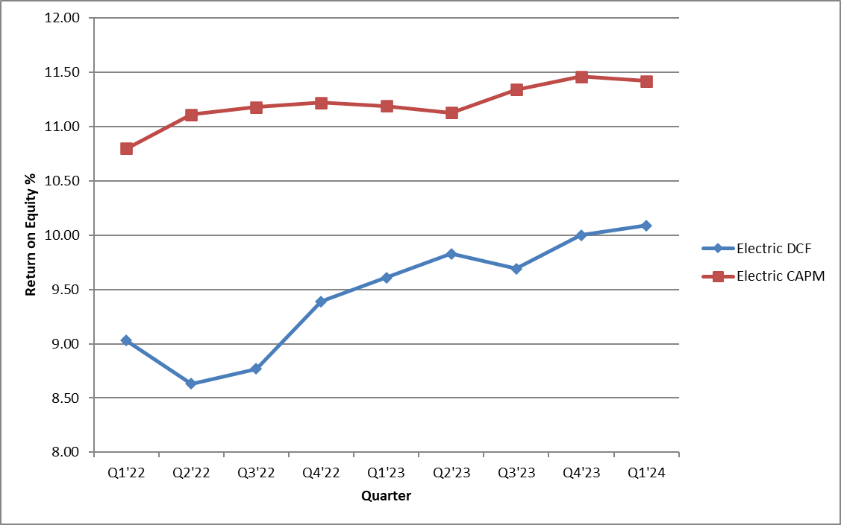

Barometer electric companies are used to calculate a current DCF in the first chart. The second chart demonstrates the companies’ 52-week average DCF. A final average of the two calculations is also shown at the bottom.

Multiple sources of the Barometer companies’ projected 5-year Earnings Per Share are used to calculate the Group Average Dividend Growth Estimate.

The market indicated common equity cost rate range consists of data used from the barometer groups and is based on a series of calculations to average the DCF methods.

Historic Gas Industry DCF and CAPM Average ROEs

Graph of Historic Gas Industry DCF and CAPM Average ROEs

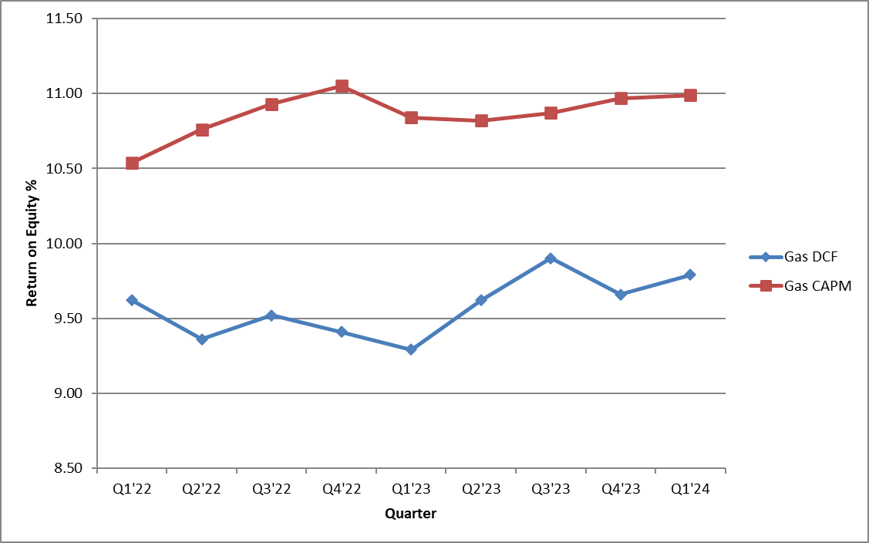

Barometer gas companies are used to calculate a current DCF in the first chart. The second chart demonstrates the companies’ 52-week average DCF. A final average of the two calculations is also shown at the bottom.

Multiple sources of the Barometer companies’ projected 5-year Earnings Per Share are used to calculate the Group Average Dividend Growth Estimate.

The market indicated common equity cost rate range consists of data used from the barometer groups and is based on a series of calculations to average the DCF methods.

Historic Water Industry DCF and CAPM Average ROEs

Chart of Historic Water Industry DCF and CAPM Average ROEs

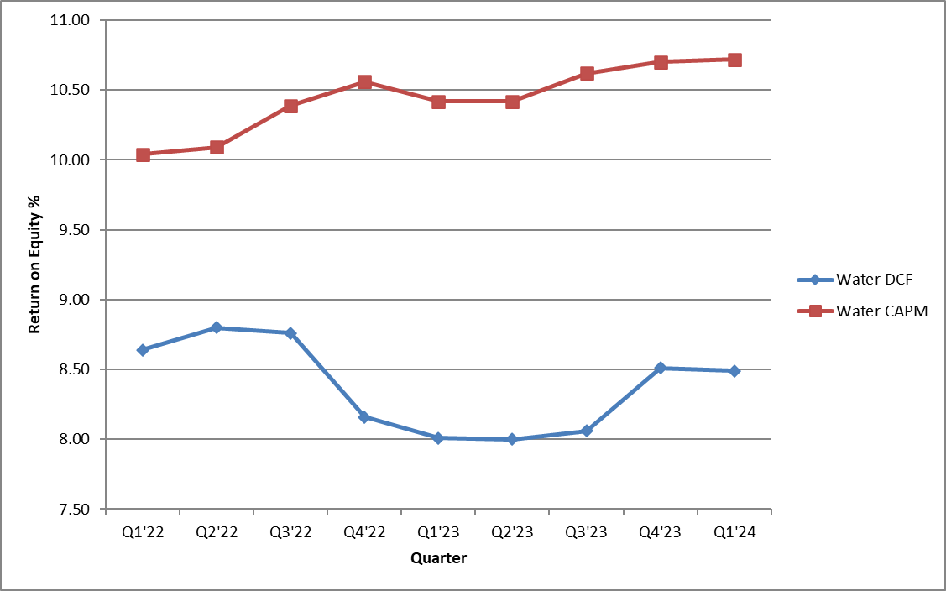

Barometer water companies are used to calculate a current DCF in the first chart. The second chart demonstrates the companies’ 52-week average DCF. A final average of the two calculations is also shown at the bottom.

Multiple sources of the Barometer companies’ projected 5-year Earnings Per Share are used to calculate the Group Average Dividend Growth Estimate.

Per Commission regulations at 52 Pa. Code § 71.3(a)(1), the major electric utilities are specifically identified by name rather than utilizing the $10,000,000 revenue threshold utilized by gas and water utilities.
Pennsylvania-American Water Company, Peoples Natural Gas Company LLC, Duquesne Light Company, PECO Energy – Electric, PECO Energy – Gas, FirstEnergy Pennsylvania Electric Co., and Aqua Pennsylvania have rate filings at Docket Nos. R-2023-3043189, R-2023-3044549, R-2024-3046523, R-2024-3046931, R-2024-3046932, R-2024-3047068, and R-2024-3047822, respectively, and have filed a letter with the Secretary in place of a report in accordance with 52 Pa. Code § 71.4.
Each utility lists adjustments on Schedule B of their quarterly financial report.
The ROE is approved in a utility's most recent fully litigated base rate proceeding for which a final order was entered not more than two years prior to the effective date of the DSIC. If more than two years have elapsed between the entry of a final order and the DSIC effective date, the ROE is from this report. If the base rate proceeding is settled, without a stipulated ROE, the ROE is from this report.

