August 27, 2025

MARVIN REDCROSS
RHINO EXPRESS, LLC
2124 FRANKLIN AVE
HARRISBURG PA 17109

Dear Mr. Redcross.:

On August 25, 2025, the Commission received the Application of Broker of Persons of Rhino Express, LLC. A bond was included in your application. At this point in the process, we cannot accept your bond. Our Motor Carrier Division will contact you at the appropriate time with instructions on when and how to file your bond.

Enclosed please find the copy of the bond and insurance card that you submitted with your application. Neither are needed currently.

Should you have any questions pertaining to your application, please contact our Bureau at 717-772-7777.

Sincerely,
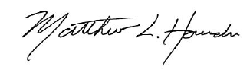

Matthew L. Homsher
Secretary

Enclosure

MH: mm

