October 1, 2025
Docket # A-2025-3057765

Jolene Busher, VP Real Estate
PO Box 218
Port Clinton, PA19549
jbusher@readingnorthern.com

Application of Reading Blue Mountain & Northern Railroad for approval to alter the public crossing (DOT # 591-819H by the abolishment of the crossing where Hill Ave/Ol Maizeville Road crosses at grade the track(s) of Reading Blue Mountain Railroad, located in the Borough of Gilberton in Schuykill County.

Dear Sir/Madam:

Receipt is acknowledged of the application of Reading Blue Mountain & Northern Railroad has been captioned and docketed to the above number.

We note that you have served copies of the application upon the parties involved.

The matter will receive the Commission's attention, and you will be advised of any further procedure.

Sincerely,
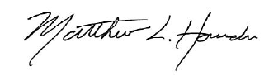

Matthew L. Homsher
Secretary

MH: mm

