October 7, 2025
A-2025-3057843

GARRETT P LENT ESQUIRE
POST AND SCHELL
17 NORTH 2ND ST 12TH FL
HARRISBURG, PA 17101-1601
glent@postschell.com

Dear Mr. Lent

Receipt is acknowledged of the Letter of Notification of PPL Electric Utilities Corporation which has been captioned and docketed to the above number.

This matter will receive the attention of the Commission and you will be advised of any further necessary procedure.

Very truly yours,
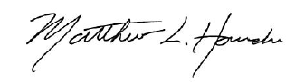

Matthew L. Homsher
Secretary

MH: mm

