 | COMMONWEALTH OF PENNSYLVANIA  PENNSYLVANIA PUBLIC UTILITY COMMISSION  COMMONWEALTH KEYSTONE BUILDING  400 NORTH STREET  HARRISBURG, PENNSYLVANIA 17120 | IN REPLY PLEASE  REFER TO OUR FILE

October 14, 2025
A-2025-3057388

TO ALL PARTIES OF RECORD

Application of the Pennsylvania Department of Transportation of
for approval to alter the public crossing (DOT 869 979 V) replacing the existing warning devices, adding gates, and installing a new high-type surface improvement where Constitution Boulevard crosses a single track of Youngstown and Southeastern Railroad; and the allocation of costs incident thereto.

To Whom It May Concern:

This is to advise that a PUC field investigation will be held at the subject crossing at 9:30 am on Thursday, November 6, 2025. The purpose of the meeting is to discuss the Pennsylvania Department of Transportation’s application to alter the subject crossing as described in the above caption.

Plan on meeting near the crossing at 3417 Martin Road, Darlington Pa. If there is no place safe to park near the crossing, we can ask to park at off to the side of the parking lot at Lance’s Port Restaurant at 3407 Constitution Ave, Darlington.

Kindly arrange to have a representative present at the subject crossing.

Very truly yours,
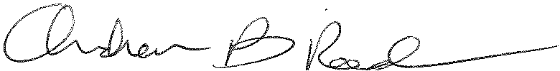
Andrew Reed, P.E.
Transportation Division - Rail Section, TUS Bureau
Phone (717) 787-4510
Email andreed@.pa.gov

