 | COMMONWEALTH OF PENNSYLVANIA  PENNSYLVANIA PUBLIC UTILITY COMMISSION  COMMONWEALTH KEYSTONE BUILDING  400 NORTH STREET  HARRISBURG, PENNSYLVANIA 17120 | IN REPLY PLEASE  REFER TO OUR FILE | IN REPLY PLEASE  REFER TO OUR FILE

November 10, 2025
A-2021-3029574 & 3029576

TO ALL PARTIES OF RECORD

Application of the Department of Transportation of the Commonwealth of Pennsylvania for approval to alter the public crossing (DOT 843 020 P) where Township Road 942, Lower Coleville Road, crosses, at grade, tracks of SEDA-COG Joint Rail Authority operated on by the Nittany and Bald Eagle Railroad in Spring Township, Centre County, and the allocation of costs incident thereto.

Application of the Department of Transportation of the Commonwealth of Pennsylvania for approval to alter the public crossing (DOT 843 019 V) by replacement of the existing structure with a concrete box culvert where Railroad Street crosses, at grade, a track of SEDA-COG Joint Rail Authority, operated on by the Nittany and Bald Eagle Railroad, in Bellefonte Borough, Centre County, and the allocation of costs incident thereto.

To Whom It May Concern:

This is to advise that a PUC final inspection will be held at the subject crossings on Monday, November 24 at 10:30 am. The purpose of the meeting is to discuss any outstanding matters, determine the acceptability of the completed work and close the proceeding. We will first meet at the crossing on Lower Coleville Road.

If you are unable to attend the final inspection and have additional issues for the Commission to consider, and/or are seeking reimbursement for any costs incurred by the project, you must inform the Commission by e-file or in writing under this docketed proceeding within twenty (20) days from the date of this letter. Please E-file or mail written objections or formal correspondence to The Secretary of the Commission, Pennsylvania Public Utility Commission, 400 North Street, Harrisburg, PA 17120 and e-mail a copy to andreed@pa.gov.

Kindly arrange to have a representative present.

Very truly yours,
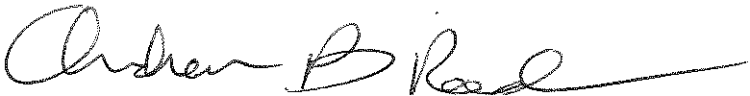
Andrew Reed, P.E.
Transportation Division - Rail Section
Bureau of Technical Utility Services
Phone (717) 787-4510
Email andreed@pa.gov

