January 8, 2026
Docket # A-2026-3059656

Suzan.D.Paiva@Verizon.com
Susan D. Paiva Assistant General Counsel
Verizon Pennsylvania LLC
900 Race Street 6th Floor
Philadelphia, PA 19107

Application of Verizon Pennsylvania LLC for approval to place a new aerial fiber and innerduct located in the Burnside Township, Clearfield County. To complete this work, we must cross R. J. Corman Railway in the public right of way of Main Street / Route 219, crossing # 527123V

Dear Sir/Madam:

Receipt is acknowledged of the application of Verizon Pennsylvania LLC has been captioned and docketed to the above number.

We note that you have served copies of the application upon the parties involved.

The matter will receive the Commission's attention, and you will be advised of any further procedure.

Sincerely,
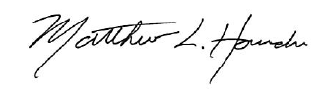

Matthew L. Homsher
Secretary

MH: mm

