 | COMMONWEALTH OF PENNSYLVANIA  PENNSYLVANIA PUBLIC UTILITY COMMISSION  COMMONWEALTH KEYSTONE BUILDING  400 NORTH STREET  HARRISBURG, PENNSYLVANIA 17120 | IN REPLY PLEASE  REFER TO OUR FILE

January 13, 2026
A-2025-3059398

TO ALL PARTIES OF RECORD

Application of the Department of Transportation of
the Commonwealth of Pennsylvania for approval to
alter the public crossing (DOT 361 207 C) by the installation of new, pre-empted, active traffic control devices and a new crossing surface where State Route 187 crosses, at grade, a track of R.J. Corman Railroad Company/Lehigh Line in Wysox Township, Bradford County and the allocation of costs incident thereto.

To Whom It May Concern:

This is to advise that the PUC field investigation and conference previously set for January 28th has been rescheduled. The field conference will be held at the subject crossing on Wednesday, February 4th 2026, at 11:00 am. The purpose of the meeting is to discuss the Pennsylvania Department of Transportation’s application to alter the subject crossing as described in the above caption.

Plan on meeting at the subject crossing. A local address near the crossing is 22549 PA-187, Wysox, PA 18854.

Kindly arrange to have a representative present at the subject crossing.

Very truly yours,
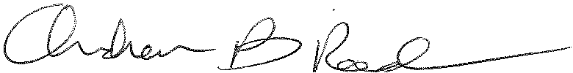
Andrew Reed, P.E.
Transportation Division - Rail Section, TUS Bureau
Phone (717) 787-4510
Email andreed@.pa.gov

