 | COMMONWEALTH OF PENNSYLVANIA  PENNSYLVANIA PUBLIC UTILITY COMMISSION  COMMONWEALTH KEYSTONE BUILDING  400 NORTH STREET  HARRISBURG, PENNSYLVANIA 17120 | IN REPLY PLEASE  REFER TO OUR FILE

November 18, 2025
C-2025-3058128

TO ALL PARTIES OF RECORD

CARL FELDMAN
Complainant

v.

MIDDLETOWN & HUMMELSTOWN RAILROAD COMPANY AND
COMMONWEALTH OF PENNSYLVANIA DEPARTMENT OF TRANSPORTION
Respondents

To Whom It May Concern:

This is to advise that a PUC field investigation and conference will be held at the public crossing (DOT 518 059 A) on State Route 0230, West Harrisburg Pike in Lower Swatara Township on Wednesday, December 17, 2025, at 11:00 am. The purpose of the meeting is to discuss the complaint of Car Feldman regarding the safe passage of bicycles over the crossing.

Plan on meeting at the crossing that is located near the entrance to Penn State Harrisburg at the intersection of First Street and West Harrisburg Pike.

Kindly arrange to have a representative present at the field conference.

Very truly yours,
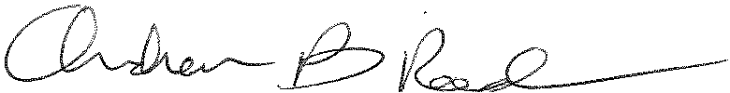
Andrew Reed, P.E.
Transportation Division - Rail Section, TUS Bureau
Phone (717) 787-4510
Email andreed@.pa.gov

