 | COMMONWEALTH OF PENNSYLVANIA  PENNSYLVANIA PUBLIC UTILITY COMMISSION  COMMONWEALTH KEYSTONE BUILDING  400 NORTH STREET  HARRISBURG, PENNSYLVANIA 17120 | IN REPLY PLEASE  REFER TO OUR FILE | IN REPLY PLEASE  REFER TO OUR FILE

May 9, 2025

A-2020-3021103
TO ALL PARTIES OF RECORD

Application of the Department of Transportation of the Commonwealth of Pennsylvania for approval to alter the five (5) public at grade crossings by the installation of new active traffic control devices where South Hoover Street, Brubaker Avenue, Custer Avenue, South Railroad Avenue and Brimmer Ave.
(SR 1011), cross the tracks of Norfolk Southern Railway Company in New Holland Borough, Lancaster County, all in accordance with the Federal Grade Crossing Program and the allocation of costs incident thereto.

To Whom It May Concern:

This is to advise that a PUC final inspection will be held at the subject crossing on Tuesday June 3, 2025, at 10:00 am. The purpose of the meeting is to discuss any outstanding matters, determine the acceptability of the completed work and close the proceeding.
Please plan on meeting at the crossing on Brimmer Avenue.

If you are unable to attend the final inspection and have additional issues for the Commission to consider, and/or are seeking reimbursement for any costs incurred by the project, you must inform the Commission by e-file or in writing under this docketed proceeding within twenty (20) days from the date of this letter. Please E-file or mail written objections or formal correspondence to The Secretary of the Commission, Pennsylvania Public Utility Commission, 400 North Street, Harrisburg, PA 17120 and e-mail a copy to andreed@pa.gov.

Kindly arrange to have a representative present.

Very truly yours,
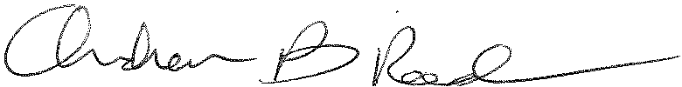
Andrew Reed, P.E.
Transportation Division - Rail Section
Bureau of Technical Utility Services
Phone (717) 787-4510
Email andreed@pa.gov

