 | COMMONWEALTH OF PENNSYLVANIA  PENNSYLVANIA PUBLIC UTILITY COMMISSION  COMMONWEALTH KEYSTONE BUILDING  400 NORTH STREET  HARRISBURG, PENNSYLVANIA 17120 | IN REPLY PLEASE  REFER TO OUR FILE

March 6, 2026
A-2026-3060631

TO ALL PARTIES OF RECORD

Application of the Pennsylvania Department of Transportation for approval to alter the public above grade crossing (DOT 510 866 U) by performing bridge preservation work and highway lighting upgrades, where SR 366 Ramp A and Ramp B crosses the tracks of Norfolk Southern Railway Company, in the Borough of Tarentum, Allegheny County, and the allocation of costs incident thereto

To Whom It May Concern:

This is to advise that the PUC field investigation and conference previously set for January 28th has been rescheduled. The field conference will be held at the subject crossing on Monday, March 16th 2026, at 1:30 pm. The purpose of the meeting is to discuss the Pennsylvania Department of Transportation’s application to alter the subject crossing as described in the above caption.

Plan on meeting at the intersection of Ross Street and 5th Avenue under the Tarentum Bridge. A local address near the crossing is 22 5th Ave Tarentum PA.

Kindly arrange to have a representative present at the subject crossing.

Very truly yours,
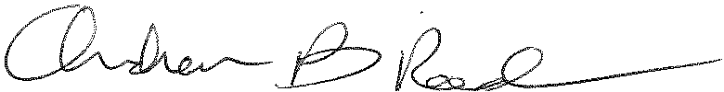
Andrew Reed, P.E.
Transportation Division - Rail Section, TUS Bureau
Phone (717) 787-4510
Email andreed@.pa.gov

