 | COMMONWEALTH OF PENNSYLVANIA  PENNSYLVANIA PUBLIC UTILITY COMMISSION  COMMONWEALTH KEYSTONE BUILDING  400 NORTH STREET  HARRISBURG, PENNSYLVANIA 17120 | IN REPLY PLEASE  REFER TO OUR FILE

March 11, 2026
C-2025-3058128

TO ALL PARTIES OF RECORD

CARL FELDMAN
Complainant

v.

MIDDLETOWN & HUMMELSTOWN RAILROAD COMPANY AND
COMMONWEALTH OF PENNSYLVANIA DEPARTMENT OF TRANSPORTION
Respondents

To Whom It May Concern:

This is to advise that a conference call will be held over Teams on
Thursday, March 19, 2026, at 11:00 am regarding the public crossing (DOT 518 059 A) where State Route 0230 (West Harrisburg Pike) crosses, at grade, a track of the Middletown and Hummelstown Railroad Company in Lower Swatara Township, Dauphin County.

This Teams call is a follow up to field conference that was held at the crossing on December 17, 2025. We are going to discuss the option to resolve the complaint by rerouting bicycle route J through Penn State Middletown’s campus and local roadways maintained by Lower Swatara Township so bicycles could avoid traversing the railroad crossing.

Once an amicable agreement is reached by all parties, the Commission will issue a Secretarial Letter to memorialize the terms of the agreement, assigning parties the items of work, associated costs, and future maintenance responsibilities.

Please refer to the electronic mail for the phone number and the link to join the call on Teams. Kindly arrange to have a representative present for the Teams call.

Very truly yours,
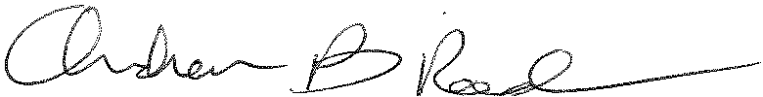
Andrew Reed, P.E.
Transportation Division - Rail Section, TUS Bureau
Phone (717) 787-4510
Email andreed@.pa.gov

