 | COMMONWEALTH OF PENNSYLVANIA  PENNSYLVANIA PUBLIC UTILITY COMMISSION  COMMONWEALTH KEYSTONE BUILDING  400 NORTH STREET  HARRISBURG, PENNSYLVANIA 17120 | IN REPLY PLEASE  REFER TO OUR FILE

April 21, 2026
A-2026-3060867

TO ALL PARTIES OF RECORD

Application of the Pennsylvania Department of Transportation for approval to upgrade two (2) public at grade crossings (DOT 051 866 B and 262 782 N) by the installation of new active traffic control devices where Mercer Street crosses, at grade. the
tracks of Western New York & Pennsylvania
Railroad, located in the City of Meadville, Crawford County all in accordance with the Federal Grade Crossing Program and the allocation of costs incident thereto.

To Whom It May Concern:

This is to advise that the PUC field investigation and conference will be held at the subject crossings on Wednesday, May 13th, 2026, at 9:30 am. The purpose of the meeting is to discuss the Pennsylvania Department of Transportation’s application to alter the subject crossings as described in the above caption.

Plan on meeting at the subject crossings which are both on Mercer Street. Use the address 177 Mercer Street, Meadville for a location in between the crossings.

Kindly arrange to have a representative present at the subject crossing.

Very truly yours,
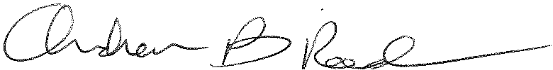
Andrew Reed, P.E.
Transportation Division - Rail Section, TUS Bureau
Phone (717) 787-4510
Email andreed@.pa.gov

