 | COMMONWEALTH OF PENNSYLVANIA  PENNSYLVANIA PUBLIC UTILITY COMMISSION  COMMONWEALTH KEYSTONE BUILDING  400 NORTH STREET  HARRISBURG, PENNSYLVANIA 17120 | IN REPLY PLEASE  REFER TO OUR FILE | IN REPLY PLEASE  REFER TO OUR FILE

May 13, 2026

A-2021-3024458,-3024460, -3024461,-3024464,-3024467

TO ALL PARTIES OF RECORD

Applications of Southeastern Pennsylvania Transportation Authority (SEPTA), for approval of the alteration of the crossings: A-2021-3024458 where Beaver Street (DOT 592 792 E )
A-2021-3024460 where Main Street (DOT 592 796 G)
A-2021-3024461 where Second Street (DOT 592 795 A)
A-2021-3024464 where Third Street (DOT 592 794 T)
A-2021-3024467 where Walnut Street (DOT 592 793 L)
cross, at grade, the tracks of the SEPTA Main Regional Rail Line located in North Wales in Montgomery County

To Whom It May Concern:

This is to advise that a PUC final inspection will be held at the subject crossings has been rescheduled. The final inspections will not be held on Tuesday May 19th.
The final inspections at the subject crossings are scheduled for Thursday May 28th 2026 beginning at 9:30 am, beginning at the crossing on Beaver Street. The purpose of the meeting is to discuss any outstanding matters, determine the acceptability of the completed work and close the proceeding.

If you are unable to attend the final inspection and have additional issues for the Commission to consider, and/or are seeking reimbursement for any costs incurred by the project, you must inform the Commission by e-file or in writing under this docketed proceeding within twenty (20) days from the date of this letter. Please E-file or mail written objections or formal correspondence to The Secretary of the Commission, Pennsylvania Public Utility Commission, 400 North Street, Harrisburg, PA 17120 and e-mail a copy to andreed@pa.gov.

Kindly arrange to have a representative present.

Very truly yours,
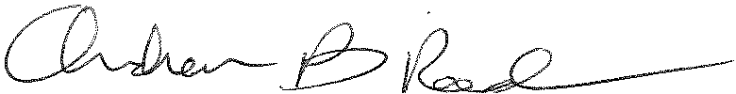
Andrew Reed, P.E.
Transportation Division - Rail Section
Bureau of Technical Utility Services
Phone (717) 787-4510
Email andreed@pa.gov

