 | COMMONWEALTH OF PENNSYLVANIA  PENNSYLVANIA PUBLIC UTILITY COMMISSION  COMMONWEALTH KEYSTONE BUILDING  400 NORTH STREET  HARRISBURG, PENNSYLVANIA 17120 | IN REPLY PLEASE  REFER TO OUR FILE | IN REPLY PLEASE  REFER TO OUR FILE

May 13, 2026

A-2023-3042164

TO ALL PARTIES OF RECORD

Application of the Department of Transportation of the Commonwealth of Pennsylvania for approval to alter two (2) public at grade crossings (DOT #145 306 G and 145 314 Y) by upgrading warning devices and replacing crossing surface where Shady Grove Road (State Route 1020) and Gallatin Road (State Route 1020) cross the tracks of Carload Express, Inc., operated ;on by Southwest Pennsylvania Railroad Company, in North Union Township, Fayette County and the allocation of costs incident thereto.

To Whom It May Concern:

This is to advise that a PUC final inspection will be held at the subject crossing on Wednesday May 27, 2026 at 11:15 am. The purpose of the meeting is to discuss any outstanding matters, determine the acceptability of the completed work and close the proceeding. Please plan on first meeting at the crossing on SR 1020 on Shady Grove Road, to the west of the intersection with Morgan Station Road.

If you are unable to attend the final inspection and have additional issues for the Commission to consider, and/or are seeking reimbursement for any costs incurred by the project, you must inform the Commission by e-file or in writing under this docketed proceeding within twenty (20) days from the date of this le0tter. Please E-file or mail written objections or formal correspondence to The Secretary of the Commission, Pennsylvania Public Utility Commission, 400 North Street, Harrisburg, PA 17120 and e-mail a copy to andreed@pa.gov.

Kindly arrange to have a representative present.

Very truly yours,
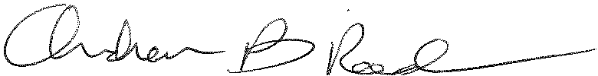
Andrew Reed, P.E.
Transportation Division - Rail Section
Bureau of Technical Utility Services
Phone (717) 787-4510
Email andreed@pa.gov

