 | COMMONWEALTH OF PENNSYLVANIA  PENNSYLVANIA PUBLIC UTILITY COMMISSION  COMMONWEALTH KEYSTONE BUILDING  400 NORTH STREET  HARRISBURG, PENNSYLVANIA 17120 | IN REPLY PLEASE  REFER TO OUR FILE | IN REPLY PLEASE  REFER TO OUR FILE

May 19, 2026
A-2021-3027435

TO ALL PARTIES OF RECORD

Application of the York County Rail Trail Authority for
approval to alter and suspend five (5) public crossings where
Pine Avenue (DOT 535 218 Y) and South East Street (DOT
535 217 S) located in the Borough of Spring Grove and where
Hershey Road (DOT 535 216 K) and Martin Road (DOT 535
215 D) located in Jackson Township cross, at grade, and
where Sunnyside Road (DOT 535 214 W) crosses, below
grade, a track of the York Railway Company, subsidiary of
Genesee and Wyoming Railroad, in York County.

To Whom It May Concern:

This is to advise that a PUC final inspection will be held at the subject crossings on Thursday May 21, 2026. The purpose of the meeting is to discuss any outstanding matters, determine the acceptability of the completed work and close the proceeding.

The final inspection will begin at 10:00 am at the suspended crossing on Pine Avenue in Spring Gove Borough. At 10:30 am, the final inspection of the crossings in Jackson Township will begin at the suspended crossing on Hershey Road.

If you are unable to attend the final inspection and have additional issues for the Commission to consider, and/or are seeking reimbursement for any costs incurred by the project, you must inform the Commission by e-file or in writing under this docketed proceeding within twenty (20) days from the date of this le0tter. Please E-file or mail written objections or formal correspondence to The Secretary of the Commission, Pennsylvania Public Utility Commission, 400 North Street, Harrisburg, PA 17120 and e-mail a copy to andreed@pa.gov.

Kindly arrange to have a representative present.

Very truly yours,
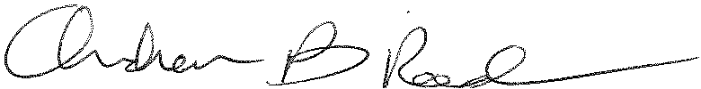
Andrew Reed, P.E.
Transportation Division - Rail Section
Bureau of Technical Utility Services
Phone (717) 787-4510
Email andreed@pa.gov

