June 4, 2026
Via Certified Mail

CANADIAN IMPERIAL BANK OF COMMERCE
NEW YORK BRANCH
300 MADISON AVENUE 5TH FLOOR
NEW YORK NY 10017

RE: Return and Release of
Letter of Credit No. SBGN151570
Rhythm Retail, LLC
PUC License A-2023-3041216

To Whom It May Concern:

Please find under cover of this Secretarial Letter the original financial instrument insuring Rhythm Retail, LLC.

The Letter of Credit from Canadian Imperial Bank of Commerce, received by the Commission on May 4, 2023, insuring this company is no longer in effect.

If there are any questions regarding the return of this bond, please contact Deb Backer, Energy Division Supervisor Bureau of Technical Utility services at dbacker@pa.gov or Stephen Jakab, Fixed Utility Financial Analyst Bureau of Technical Utility Services at sjakab@pa.gov.

Sincerely,
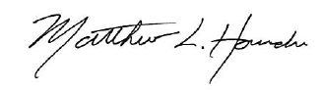

Matthew L. Homsher
Secretary of the Commission

Enclosures: Original Letter of Credit No. SBGN151570

cc: Michael A. Gruin, Esq.

