 | COMMONWEALTH OF PENNSYLVANIA  PENNSYLVANIA PUBLIC UTILITY COMMISSION  COMMONWEALTH KEYSTONE BUILDING  400 NORTH STREET  HARRISBURG, PENNSYLVANIA 17120 | IN REPLY PLEASE  REFER TO OUR FILE | IN REPLY PLEASE  REFER TO OUR FILE

June 17, 2026

A-2021-3024204
TO ALL PARTIES OF RECORD

Application of the Department of Transportation of the
Commonwealth of Pennsylvania for approval to alter the
public crossing (DOT No. 545 164 X) by removing the
existing overhead bridge and constructing a new bridge on
a new alignment where State Route 1060 (Bridge Street)
crosses over the tracks of Norfolk Southern Railway
Company and over the Kiskiminetas River in Bell
Township, Westmoreland County and in Kiskiminetas
Township, Armstrong County; and the allocation of costs
incident thereto.

To Whom It May Concern:

This is to advise that a PUC final inspection will be held at the subject crossing on Tuesday July 7th at 1:30 pm. The purpose of the meeting is to discuss any outstanding matters, determine the acceptability of the completed work and close the proceeding.

If you are unable to attend the final inspection and have additional issues for the Commission to consider, and/or are seeking reimbursement for any costs incurred by the project, you must inform the Commission by e-file or in writing under this docketed proceeding within twenty (20) days from the date of this le0tter. Please E-file or mail written objections or formal correspondence to The Secretary of the Commission, Pennsylvania Public Utility Commission, 400 North Street, Harrisburg, PA 17120 and e-mail a copy to andreed@pa.gov.

Kindly arrange to have a representative present. Please plan on meeting at the southern side of the bridge, the side closest to Salina. GPS coordinates are 40°31'27.4"N 79°29'39.5"W.

Very truly yours,
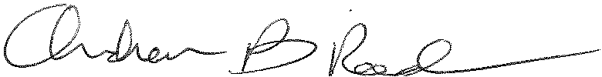
Andrew Reed, P.E.
Transportation Division - Rail Section
Bureau of Technical Utility Services
Phone (717) 787-4510
Email andreed@pa.gov

